

WESTERN BALKANS SALW CONTROL ROADMAP
MULTI-PARTNER TRUST FUND

Narrative Progress Report
January – December 2025

Project Title & Project Number |  |  | Country, Locality(ies), Priority Area(s) / Strategic Results
- Project Title: Reduce Risk - Increase Safety III  - Project Number: 01001015  - MPTF Office Project Reference Number: 00140406 |  |  | (if applicable)  Country/Region  Serbia
Priority area/ strategic results
SDG 5, SDG 16
SALW Control Roadmap – Goals 2 and 4
Participating Organization(s) |  |  | Implementing Partners
- Organizations that have received direct funding from the MPTF Office under this project  UNDP Serbia |  |  | - National counterparts (government, private, NGOs & others) and other International Organizations  Ministry of Interior, Institute for Public Health of Serbia “Dr Milan Jovanovic Batut”
Project Cost (US$) |  |  | Project Duration
Total approved budget as per project document:  MPTF /JP Contribution:  - by Agency (if applicable) | $1, 026,135 |  | Overall Duration | 38 months
Agency Contribution  - by Agency (if applicable) |  |  | Start Date | 31 October 2023
Government Contribution  (if applicable) |  |  | Original End Date | 29 October 2025
Other Contributions (donors)  (if applicable) |  |  | Current End date | 31 December 2026
TOTAL: | $1, 026,135
Project Assessment/Review/Mid-Term Eval. |  |  | Report Submitted By
Assessment/Review - if applicable please attach  Yes No Date: dd.mm.yyyy  Mid-Term Evaluation Report – if applicable please attach  Yes No Date: dd.mm.yyyy |  |  | - Name: Maja Brankovic Djundic  - Title: Gender Inclusivity Analyst - Portfolio Manager  - Participating Organization (Lead): UNDP Serbia  - Email address: maja.djundic@undp.org

I. Background
Recognizing that firearms misuse is a gender problem which continues to affect the lives of citizens of Serbia, the project contributes to decreasing the risk of firearms misuse that leads to violence and suicides. The project also focuses on strengthening the role of women as active participants in SALW control and the implementation of the Roadmap for a Sustainable Solution to the Illegal Possession, Misuse and Trafficking of Small Arms and Light Weapons (SALW), their Ammunition and Explosives in the Western Balkans (the Roadmap). The project aims to foster collaboration and knowledge exchange of relevant stakeholders and enhance community response to firearms-related crises and trauma, with a view of restoring the feeling of safety in the wider community.

The project intends to build upon and consolidate the achieved implementation of the SALW Control Roadmap, by focusing on gaps and challenges identified under Goal 2: By 2030, ensure that arms control policies and practices in the Western Balkans are in place, evidence-based and intelligence-led, and Goal 4: By 2030, significantly reduce the supply, demand, illicit possession and misuse of arms, ammunition and explosives through the means of prevention.

The project is based on the following relevant evidence which indicates the impact of SALW misuse:

- 28% of all fatalities from firearm incidents occurred in the domestic setting in the Western Balkans from 2019 to 2024. Domestic violence (DV) was the most lethal context for women when firearms were involved, with the number of women victims doubling over the years. 68% of all women killed in firearm incidents in the Western Balkans in the period 2019-2024, were killed by their intimate partners or family members while the same holds true for 12% of men killed with firearms. An additional problematic trend is that domestic violence involving firearms had the highest number of fatalities of all other types of incidents, even though it accounted for far fewer reported incidents compared to criminal contexts, public disputes, and undetermined shootings.

- Based on media reports, 18 femicides occurred in Serbia in 2025, with three femicide-suicide cases, and six cases where sons killed their mother. 17 femicides occurred in Serbia in 2024 in a domestic/intimate-partner or gender-based violence context, a third of them with firearms (29%). In six of these cases the perpetrators committed suicide. There were 28 femicides in Serbia in 2023. A total of 20 cases (70%) occurred in the context of domestic/intimate - partner violence and 11 (39%) femicides were committed with firearms (based on media reports).
- The total number of intimate-partner femicide-suicide cases committed with a firearm, varies. The share of firearms-enabled femicides followed by suicide of the perpetrator in the last decade was the highest in 2017 - 57.69%, and the lowest in 2016 - 18.16%.

- The majority of mass murders in Serbia in the previous years were committed with firearms, and their backgrounds were either tied directly to domestic violence or involved the killing of the perpetrator’s partner and the partner’s family members. Women and girls account for the majority of the victims of these mass shootings, while the perpetrators are men.

- In 2024, 702 suicides were recorded in Serbia, which is 34 cases more than in 2023. The number of suicides in 2023 was 668, by 102 cases less than in 2022. Men are the majority of persons who commit suicide - 75%.

- In 2024, 55 people died by firearm-enabled suicide in SEE, 18% less than in 2023 (with men as a majority). In 2022, 62 people died by firearm-enabled suicide in SEE, 37% more than in 2021. In both 2020 and 2021, Serbia was the highest-ranking country in the SEE region with regards to firearm-related suicides, however the number of reported suicides more than halved in 2021 (14 cases), compared to 2020.

- Media reporting on firearm misuse in Serbia is insufficiently contributing to the recognition or prevention of firearms-misuse risks in a domestic context or for suicides, with media likely to shift responsibility for violence from the perpetrator to the survivor/victim, disclose irrelevant details of the act of violence or diminish violence.

The project aims to encourage changes of harmful social norms and reduce the risk of firearms misuse by persons who have access to firearms as civilians, or based on their occupation or hobby, as well as those who have access to illegal firearms. The overall goal is to contribute to the meaningful integration of a gender perspective into SALW control policies.

UNDP’s efforts play a significant role in complementing and accelerating the impact of measures introduced by the Government of Serbia in response to the May 2023 mass shootings using a comprehensive approach to firearms misuse prevention and building overall safety in the country. The project also contributes to the implementation of the Law on Weapons and Ammunition, Law on Prevention of Domestic Violence, National Strategy for Combating Domestic Violence, National Strategy for the Realization of the Rights of Victims and Witnesses of Criminal Offenses in the Republic of Serbia for the Period 2020–2025, as well as National Strategy on SALW Control 2019-2025.

II. List of Acronyms

Batut Institute for Public Health of Serbia “Dr Milan Jovanovic Batut”
BiH Bosnia and Herzegovina
CSO Civil society organizations
DV Domestic violence
ENP European Network of Policewomen
EU European Union
GBV Gender - based violence
LWA The Law on Weapons and Ammunition
LPDV The Law on Prevention of Domestic Violence
MD Multidisciplinary team for establishing a Memorial center in remembrance of victims of the mass
murders in the “Vladislav Ribnikar” Elementary School in Belgrade
MOH Ministry of Health
MoI Ministry of Interior
NGO Non-governmental organization
NKTVS Norwegian Center for Violence and Traumatic Stress Studies
PD Police Department
Roadmap Roadmap for a Sustainable Solution to the Illegal Possession, Misuse and Trafficking of Small
Arms and Light Weapons (SALW) and their Ammunition in the Western Balkans
SALW Small arms and light weapons
SEE Southeast Europe
ToT Training of Trainers
UNDP United Nations Development Programme

III. Executive Summary
In 2025, the project achieved significant progress in reducing the risks and impacts of firearms misuse through a comprehensive, multi-sectoral approach addressing domestic violence, suicide prevention and post-crisis recovery. The project strengthened evidence-based policymaking, enhanced institutional capacities, empowered communities and promoted responsible public communication, contributing to safer and more resilient environments.

At the policy level, the project advanced gender-responsive and evidence-based governance by developing evidence-based recommendations that informed amendments to the Law on Prevention of Domestic Violence. This was supported by comprehensive mapping of crisis-response resources and assessment of victim and witness protection systems, providing a strong foundation for improving survivor-centered responses. In parallel, efforts to improve administrative data collection within the Ministry of Interior contributed to more systematic and gender-sensitive monitoring of firearm-related incidents.

The project strengthened the visibility, leadership and influence of women in policing through large-scale national and regional networking initiatives, including a high-level conference gathering 127 participants (91 women and 36 men) from 18 jurisdictions. Regional cooperation was enhanced through bilateral exchanges between Serbia and Bosnia and Herzegovina, gathering 26 women from the police, through knowledge exchange, leadership discussions and practical skill-building.

Institutional capacities were strengthened across key sectors. Within the healthcare system, a specialized training programme and a risk assessment tool were developed to support early detection of risks related to firearm misuse. In the security sector, 261 police officers (67 women and 194 men) were trained to improve risk assessment and response to domestic violence cases. Psychosocial support systems for prevention of suicides among police officers were reinforced through regional exchanges involving 58 police psychologists from 5 jurisdictions (53 women and 5 men) and continued supervision of previously trained 31 mental health professionals (24 women and 7 men) delivering trauma-informed care to individuals affected by mass shootings.

At the community level, the project expanded prevention and support mechanisms through partnerships with civil society. Four women’s organizations directly empowered over 390 women, with their support services reaching more than 140 women and over 2,100 awareness materials were disseminated to increase public understanding of firearm-related risks and promote safe reporting.

Efforts to shift harmful social norms and reduce stigma regarding suicide were advanced through developed training that enabled 11 army veterans to recognize risks related to firearms-misuse for suicide and provide support in the veteran community.

Work continued on the analysis of media reports on May 2023 mass shootings, contributing to evidence-based foundations for ethical and prevention-oriented media reporting.

One of the project’s most notable achievements in 2025 was the clear demonstration of institutional ownership and sustainability within the Ministry of Interior. During the 16 Days of Activism global campaign, the Ministry independently conceived and implemented nationwide awareness efforts, drawing on project support only for promotional materials. The fact that police officers carried the campaign forward through local actions across the country showed that prevention-oriented outreach has been internalized within MoI structures, marking an important step toward sustainable, system-led action beyond the life of the project.

###

The following represents an overview of activities under the “Reduce Risk – Increase Safety III” project, implemented in the period from January to end of December 2025:

Output 1.1 Gender and age data collection practices reviewed, and evidence-based policy making and practice enhanced to address risks of firearms enabled violence and other forms of firearm misuse, aims to support the MoI in enhancing its administrative data collection processes, with a focus on addressing missing data sets and improving data classification related to gender and age, as well as provide evidence-based recommendations and resources to improve systematic approaches for preventing and reducing risk of firearms misuse in gender-based violence and mass shootings.

In the reporting period, the project contributed to more informed, coordinated, and survivor-focused institutional responses:

- Evidence-based policymaking on firearms misuse was significantly strengthened through completed multi-sectoral recommendations that directly informed amendments to the Law on Prevention of Domestic Violence.
- Completed comprehensive mapping of crisis-response resources and rapid assessment of victim and witness protection systems provided a robust evidence base for improving survivor-centered responses to mass shootings and firearm-related violence.
- Based on the previously developed comprehensive dataset framework needed for generating analytical report on firearms misuse for DV, MoI continued to further identify missing data sets and assess how these data could be extracted from existing records or incorporated into the data management system to address gaps., contributing to improved data collection processes.

Output 1.2 Networking and capacity building of women to actively participate in SALW control policies strengthened, aims to support greater integration of the gender perspective into SALW control policies, contributing to the efforts to improve the inclusion of women in SALW control and strengthen further networking of women professionals in security forces.

In the reporting period, the project contributed to stronger participation of women in security governance and the advancement of gender-responsive security policies:

- The project strengthened the visibility, leadership, and influence of women in policing through large-scale national and regional networking initiatives, including a conference gathering 127 participants (91 women and 36 men) from 18 jurisdictions.
- Regional and international cooperation was enhanced through support to the European Network of Policewomen (gathering 16 women police representatives from the region and Europe) and bilateral exchanges between Serbia and Bosnia and Herzegovina, gathering 26 women through knowledge exchange, leadership discussions and practical skill-building.

Output 2.1. Conditions ensured for improved detection of potential firearms misuse for domestic violence and suicides and comprehensive prevention support aims to enhance capacities of institutions within the healthcare system for improved filtration of persons at risks of firearms misuse, as well as healthcare’s collaboration with other institutions, to enhance the management of domestic violence cases, taking into account the victims’ safety.

Progress towards the output includes:
- Contribution to strengthening healthcare system’s role in firearms misuse prevention through developed training programme on addressing firearms misuse risks for violence through health professionals’ practices.
- Furthermore, a risk assessment pilot tool for firearm licensing was developed with a view of better misuse risks detection and prevention through health checkups as part of the firearms licensing procedures.
- Contribution to improved risk management among first-responders, through training of 261 police officers (67 women and 194 men) on domestic violence risk assessment and survivor-centered measures.
- Enhanced local community safety by enabling 4 local CSOs (selected based on a published call) to implement activities regarding the protection of women from firearms-enabled violence. With the project’s support they have directly empowered 390 women to recognize risks of firearm misuse and take protective actions, 143 institutional representatives (116 women and 27 men) from police, judiciary, healthcare and social services were engaged through multi-stakeholder dialogues to strengthen coordinated responses. NGO helplines provided psychosocial, legal, and safety assistance to over 140 women, contributing to improved protection outcomes, while over 2100 leaflets and posters were produced and disseminated to increase public understanding of firearm-related risks and promoting safe reporting of violence.

Output 2.2 Information on the harmful effects of underlying practices and attitudes leading to firearms misuse and supportive mechanisms preventing suicides enhanced, aims to change mindsets and debunk prejudices that prevent particularly men from seeking mental health support and to deter the misuse of firearms for violence and suicide.

In 2025, the project contributed to shifting attitudes towards violence reporting, promoting help-seeking, and embedding sustainable prevention approaches within institutions and communities.

- Awareness-raising efforts contributed to increased public knowledge and trust in domestic violence reporting mechanisms, reaching citizens through nationwide local actions organized by MoI.
- Institutional capacity for mental health and suicide prevention was strengthened through regional and national knowledge exchange on improved psychosocial support systems for police officers, gathering 89 police psychologists (83 women and 6 men) from 5 jurisdictions.
- Targeted interventions addressed high-risk firearms misuse groups, including men over 45, through tailored suicide prevention training reaching 11 army veterans (all men), knowledge materials, and stigma-reduction messaging.

Output 2.3 Best practice sharing enabled with professionals, media and academia on effective mechanisms for prevention of future firearms related incidents, aims to identify and transfer best practices from other countries in terms of emergency support programs and long-term community reintegration, as well as measures that have proven effective in preventing occurrence of similar cases in the future.

Within the reporting period, the project contributed to building a knowledge-driven, collaborative approach to prevention, recovery, and responsible public communication.

- Capacities for trauma-informed response were strengthened through continued supervision of previously trained 31 mental health professionals (24 women and 7 men), ensuring sustained support to victims of mass shootings.
- Analysis of media reporting on mass shootings was continued through work of the group Journalists against Violence, laying the groundwork for ethical and prevention-oriented media guidelines.

Brief contextual analysis

Throughout 2025, Serbia’s socio-political environment was marked by continued public unrest triggered by the collapse of the canopy at the Novi Sad railway station in November 2024, which resulted in 16 fatalities and catalyzed widespread demands for accountability and systemic reforms. The incident sparked nationwide protests initially led by students and later joined by broader segments of civil society, including educators, legal professionals and civic activists. Demonstrations persisted throughout the year across major urban centers, reflecting growing public dissatisfaction and political polarization. The crisis contributed to significant political developments, including the resignation of Prime Minister Milos Vucevic in January 2025 and the subsequent formation of a new government in April under Prime Minister Djuro Macut. However, the change in government did not substantially ease public discontent, and large-scale protests continued, including major demonstrations in Belgrade calling for early elections and increased institutional accountability. International actors, including UN and EU representatives, monitored the situation and emphasized the importance of safeguarding the right to peaceful assembly.

The volatile context influenced the implementation environment for the project. Frequent police deployments to secure protests affected the availability of Ministry of Interior personnel for project activities, while institutional uncertainty and strained relations between authorities and civil society limited cooperation with some project partners. Despite these challenges, the project team adopted an adaptive management approach, maintaining close coordination with institutional stakeholders and civil society partners. Flexible scheduling, revised activity timelines, and no-cost extensions for selected community initiatives enabled the continuation of key activities, including cooperation with the Ministry of Interior and the Network of Women in the Police of Serbia. By the end of 2025, although the socio-political environment remained tense, particularly around the first anniversary of the Novi Sad tragedy, project implementation continued with steady progress toward planned outputs.

Note on project extension

Following the Trust Fund Steering Committee’s decision in September 2025, the project was extended in scope, budget (additional $250,000 to the initial budget of $776,135), and duration (until end of December 2026) to address emerging priorities, based on learnings during implementation, while building on existing efforts. The extension focuses on scaling up successful interventions related to trauma-informed support, ethical media practices, and firearms risk detection, integrating lessons from Serbia’s 2023 mass shootings into national and regional SALW control policies and practices. It also aims to deepen collaboration with the Ministry of Interior and the health sector by piloting new tools to enhance firearm licensing procedures and misuse risk detection and reinforcing the role of mental health professionals. Additionally, the project aims to expand existing regional cooperation through networks of women in the police to further strengthen the gender perspective in SALW control, with targeted support for advocacy and women’s empowerment.

Budget implementation
The project’s budget has been utilized as planned in the reporting period and in accordance with the revised budget as per the project extension. The total project’s expenditure by the end of the reporting period is USD $564,143.43. Further details are provided in the relevant sections of the report and the annexed provisional financial report.

IV. Overview of progress towards results (for Annual and Final Reports only)
Project output | Project output indicator | Target | Status of project results  (please select one of the following options: [result] achieved/ partially achieved/ not achieved/ activities not initiated) | Achievements against indicators and targets
Output 1.1: Gender and age data collection practices reviewed, and evidence-based policy making and practice enhanced to address risks of firearms enabled violence and other forms of firearm misuse | - The data collection  practices of the Ministry of Interior (MoI) related to firearms misuse in the context of domestic violence reviewed to incorporate missing sex and age disaggregated data.  1.1.2. Evidence based recommendations to improve  victim-centered systematic approaches for preventing and reducing risk of firearms misuse in gender-based violence and mass shootings developed | 1.1.1. YES  Recommendations for improved data collection to include sex and age sensitive data endorsed by MoI  1.1.2. YES  Evidence based recommendations to improve systematic approaches for preventing and reducing risks of firearms misuse in gender-based violence and mass shootings developed and validated | Partially achieved | 1.1.1. Completed comprehensive framework for datasets to be collected and analysed by MoI to generate analytical reports on misuse of firearms in the context of domestic violence (including incorporation of missing se and age disaggregated data). The framework was presented and discussed with several MoI sectors, including the Sector for analytics, telecommunications and information technology, as well as departments responsible for prevention and combating of domestic violence and for administrative affairs.  The MoI has continued work to further identify missing data sets and assess how these data could be extracted from existing records or incorporated into the data management system to address gaps.  1.1.2.Completed evidence-based recommendations to strengthen legal and institutional mechanisms for preventing and reducing the risk of firearms misuse in gender-based and domestic violence, validated through consultative process involving representatives of police, judiciary, social welfare institutions and civil society. The recommendations informed the work of the Ministry of Justice of the Republic of Serbia working group drafting amendments to the Law on the Prevention of Domestic Violence.  Drafted comprehensive mapping of crisis response resources for victims of mass-shooting incidents and professionals responding to such crises in Serbia, covering protocols, communication mechanisms, immediate and long-term support services, and lessons learned from previous incidents, including direct feedback from those affected by the May 2023 mass shootings.  Completed rapid assessment of institutional mechanisms for the protection of victims and witnesses of crime, including firearm-related offenses, identifying existing services, systemic gaps and opportunities for strengthening victim and witness support systems.
Output 1.2: Networking and capacity building of women strengthened to actively participate in SALW control policies | 1.2.1. No of women police officers, including members of the Network of Women in the Police capacitated to participate in the development, advocacy and implementation of gender-responsive SALW control policies  1.2.2. Improved regional experience exchange and networking of the women police officials in Serbia and Bosnia and Herzegovina on gender mainstreaming in SALW control policies and SALW control. | 1.2.1. At least 50 women from security sector trained on issues relating to development and implementation of gender sensitive SALW control policies  1.2.2.a Up to 100 participants at the regional experience exchange and networking  meetings  1.2.2.b Up to 21 members of the regional networks are introduced to different international best practices during a study visit to a sister network in an EU country | Partially achieved | 1.2.1. 233 women from the security sector, including members of the Network of Women in the Police, networked around the topic of prevention of (firearms-enabled) DV and gender sensitive SALW control policies.  1.2.2.a 70 women, members of associations of  women in the police from Serbia and BiH networked through three bilateral meetings.  1.2.2.b. Not yet initiated
Output 2.1 Conditions ensured for improved detection of potential firearms misuse for domestic violence and suicides and comprehensive prevention support | 2.1.1. No. of healthcare professionals trained to identify risks and effectively implement procedures for reporting and addressing suspected risk of firearms related domestic violence.  2.1.2. Recommendations for the new Rulebook on determining natural persons' ability to hold and carry weapons within healthcare system developed and validated by relevant entity.  2.1.3. Number of standardized risk assessment tools for healthcare professionals developed and piloted and model for inter-institutional coordination finalized and disseminated.  2.1.4. Number of trained police officers on (firearms-misuse) risk assessment in domestic violence cases delivered.  2.1.5. Number of CSOs engaged for community based actions. | 2.1.1. At least 180 health care professionals trained to better detect and manage cases of violence in collaboration with the police and prosecutor's office  2.1.2. YES  Recommendations for the new Rulebook on determining natural persons' ability to hold and carry weapons within healthcare system developed and validated by the relevant entity.  2.1.3.One standardized risk assessment tool for healthcare professionals, and a model for inter-institutional coordination developed and piloted, enhancing systematic firearm risk management and communication between healthcare and security sectors.  2.1.4. Up to 300 professionals take part in consultative meetings/trainings/ learning sessions  2.1.5. Up to 4 CSOs supported to develop and implement community-based actions targeting women whose family members have access to firearms and collaborate with institutions | Partially achieved | 2.1.1. 215 healthcare and legal professionals (187 women and 28 men) from 67 municipalities received training from the project start, to improve their ability to identify risks of firearms misuse in violence and ensure victim safety.  2.1.2. Not yet initiated.  2.1.3. One standardized risk assessment pilot tool developed (format, scoring method, intended users and usage cases) for healthcare professionals when conducting medical assessments for firearm license applicants. Consultative expert group consisting of institutional and NGO representatives formed to ensure alignment with official procedures and ownership over tool testing and application  in the upcoming period.  2.1.4. 261 police officers (67 women and 194 men) from over 40 municipalities trained on risk assessment and coordinated responses to domestic violence cases involving firearms misuse.  2.1.5 4 CSOs supported by the project to contribute to increased community safety and protection of women from firearms-enabled violence. The CSOs provided local helpline support to over 140 women, trained 390 women to recognize risks of firearm misuse and take protective actions, networked 143 institutional representatives (116 women and 27 men) to strengthen coordinated response and raised community awareness on the dangers of firearms-misuse for violence against women by disseminating over 2100 printed materials.
Output 2.2 Information on the harmful effects of underlying practices and attitudes leading to firearms misuse and supportive mechanisms  preventing suicides enhanced | 2.2.1. MoI media communication capacities and campaigns to prevent firearms misuse in the community and domestic violence context in place  2.2.2. Professionals providing psychological support within MoI capacitated and police officers informed on supportive mechanisms to prevent negative consequences of professional trauma.  2.2.3. Development of a training curriculum, as well as the training of trainers, aimed at strengthening healthcare system capacities to identify and support individuals at risk of suicide. | 2.2.1. YES  At least 20 media reports containing information about the consequences of firearms misuse as well as critical reviews of firearms (mis)use for domestic violence and gender-based violence  2.2.2.a  At least 25 professionals from MoI’s Department of Psychological Activities trained to prevent negative consequences of professional trauma  2.2.2.b YES - informative activities conducted by the Department among different police units  2.2.3.a YES ToT curriculum developed on how to recognize and provide further and adequate support to persons at risks of committing suicide  2.2.3.b up to 15 trainers from the healthcare system trained on how to recognize and provide adequate support to persons at risks of committing suicide | Partially achieved | 2.2.1. 50 media reports containing information about consequences of domestic violence (including through firearms misuse) published in traditional and electronic media.  2.2.2.a. 31 (30 women and 1 man) representatives of the MoI Department of Psychological Activities, local PD psychologists, heads of police stations and officers in charge of recruitment, were trained on reducing negative consequences of professional trauma, including those affecting mental health experienced by professionals involved in violent events with firearms. An additional 31 MoI police psychologists (30 women and 1 man) gained knowledge on regional good practices regarding psychosocial support systems for police officers and strengthened cooperation with local NGO specializing in supporting persons in psychological crisis.  2.2.2.b YES – completed in previous reporting period involving 51 MoI representatives (31 women and 20 men, from 29 local police departments.  2.2.3.a Developed one-day training curriculum on prevention of firearm misuse for suicide for high-risk population, utilized to deliver targeted training to 11 army veterans, improving their ability to recognize (firearms-enabled) suicide risks, respond to psychological crisis situations, and promote safe behaviors among peers, contributing to community-level prevention efforts.  ToT is developed and selection of trainers is in progress.  2.2.3. b Not yet initiated
Output 2.3. Best practice sharing enabled with professionals, media and academia on effective mechanisms for prevention of future firearms related incidents | 2.3.1. International best practices on post-tragedy/mass shooting community reintegration mapped and shared with professionals, media and academia  2.3.2. Number of journalists with increased capacities and networking opportunities to engage in preventive and ethical reporting on firearms-enabled gender-based violence, including mass shootings | 2.3.1.a Effective practices that have been implemented internationally to improve prevention and response to firearm misuse incidents, including mass shootings mapped and applied.  2.3.1.b At least 30 mental health professionals participate in training/knowledge exchange sessions, on applying best practices in providing mental health support to persons directly or indirectly affected by consequences of mass shooting  2.3.2.a Analysis of media reporting on firearms-related incidents conducted  2.3.2.b Up to 10 journalists participate in a study trip to a European media hub to exchange specialist knowledge on the most challenging of media issues and encourage media networking related to ethical reporting on violence and trauma will be organized  2.3.2.c Up to 100 participants/ women journalists from the region participate in events that encourage networking, preventive reporting related to firearms-enabled gender-based violence, including mass shootings | Partially achieved | 2.3.1.a Expert from the Brussels-based organization Victim Support Europe identified key action points for healing and reconciliation within the community following the mass shootings at “Vladislav Ribnikar” Elementary School and villages of Mala Dubona and Orašje. The expert participated in the Government’s working group to support the first commemoration of the May 2023 mass shootings and provided insight and support to the group based on international best practices on overcoming post-tragedy/mass shootings trauma and community healing.  2.3.1.b 31 mental health professionals (24 women and 7 men) strengthened competencies and capacities in providing Trauma-Focused Cognitive Behavioral Therapy for children, adolescents and families who are direct or indirect victims of mass shootings and received continuous supervisory support by Norwegian experts throughout a period of one year. This is part of the project’s direct response to enhancing resilience to and overcoming trauma in the aftermath of the May 2023 mass shootings.  2.3.2.a 11 trained journalists are implementing media reporting analysis of approx. 8000 articles, based on developed methodology and overview of dominant narratives on the topic of May 2023 mass murders. To complement this media monitoring, analysis of images used in media reports on the mass shooting events was drafted. The analysis was initiated with the approval of the Multidisciplinary team for establishing a Memorial center in remembrance of victims of the mass murders in the “Vladislav Ribnikar” Elementary School in Belgrade.  2.3.2.b Not yet initiated  2.3.2.c Not yet initiated

IV. Progress review
Output 1.1: | Gender and age data collection practices reviewed, and evidence-based policy making and practice enhanced to address risks of firearms enabled violence and other forms of firearm misuse
Total budget: | $ 36,800 | Spent:  $ 26,579.14 | Balance: $ 10,220.86

1. Progress towards the output
The project aims to support the MoI in enhancing its administrative data collection processes, with a focus on addressing missing data sets and improving data classification related to gender and age. The aim is to improve data collection to include a gender context, to ensure a more comprehensive and accurate data management system within the MoI. Furthermore, the project will organize a task force of experts working on domestic violence prevention and protection, to evaluate the efficacy of current legal solutions and measures related to domestic violence. The screening will identify missing bylaws and procedures that could facilitate a more effective application of laws in practice, to enhance victim protection. The project will also work to provide trauma-informed and evidence-based recommendations for ensuring an efficient and integrated approach to firearms-related crisis response and prevention, as well as strategies for overcoming trauma caused by mass shooting incidents.

Within the reporting period, evidence-based recommendations to improve legal and institutional responses to firearms misuse in domestic violence were developed through multi-sectoral consultations and informed the work of the Ministry of Justice of the Republic of Serbia working group drafting amendments to the Law on the Prevention of Domestic Violence. In addition, the project completed a comprehensive mapping of crisis-response resources for victims of mass-shooting incidents and professionals responding to such crises, alongside a rapid assessment of institutional mechanisms for victim and witness protection. Together, these analyses identified systemic gaps and survivor needs, providing a strong evidence base for strengthening integrated, survivor-centred crisis response and prevention mechanisms related to firearms misuse.

2. Description of activities implemented during the reporting period

Activity 1.1.1: Provide technical and consultative assistance in analyzing current data collection methodologies related to gender and age and revision of missing gender and age-related data

- During the reporting period, UNDP held regular communication with the MoI regarding the enhancing of data collection practices, upon the completion and presentation of the comprehensive framework for datasets necessary for generating analytical reports on the misuse of firearms in the context of domestic violence. The MoI has continued work to further identify missing data sets and assess how these data could be extracted from existing records or incorporated into the data management system to address gaps.

Activity 1.1.2: Development of evidence-based recommendations and resources to improve systematic approaches for preventing and reducing risk of firearms misuse in gender-based violence and mass shootings
- In the reporting period, the project completed evidence-based recommendations to strengthen legal and institutional mechanisms for preventing and reducing the risk of firearms misuse in gender-based and domestic violence, The recommendations include practitioners’ insights on challenges and good practices in preventing domestic and partner violence involving firearms collected through four multi-sectoral focus group discussions with 24 professionals (16 women and 8 men) from the police, judiciary and social welfare system in Serbian appellate court seats Belgrade, Novi Sad, Kragujevac and Niš. The recommendations were validated through a multi-sectoral consultative process involving 14 representatives (11 women and 3 men) from police, judiciary, social welfare institutions and civil society.
Furthermore, the project ensured that the recommendations informed national policy processes, including the work of the Ministry of Justice of the Republic of Serbia working group drafting amendments to the Law on the Prevention of Domestic Violence, with the aim of improving victim protection and addressing risks linked to perpetrators’ access to firearms.
- Additionally, a comprehensive mapping of crisis response resources was drafted for victims of mass-shooting incidents and professionals responding to such crises in Serbia, covering protocols, communication mechanisms, immediate and long-term support services, and lessons learned from previous incidents, including direct feedback from those affected by the May 2023 mass shootings. The recommendations will be validated by the participants of the mapping exercise (persons directly affected by mass victimization incidents and responding professionals) to inform finalization and further utilization of findings.
- Moreover, a rapid assessment of institutional mechanisms for the protection of victims and witnesses of crime, was also completed, including firearm-related offenses, identifying existing services, systemic gaps and opportunities for strengthening victim and witness support systems.
The above mapping exercises represent a comprehensive evidence base on survivor needs and crisis-response capacities, including the needs of direct and indirect victims, as well as first responders, to inform recommendations for strengthening integrated, survivor-centred crisis response and prevention mechanisms in cases involving firearms misuse.

3. Difficulties encountered, and measures taken to overcome the problems
- No difficulties encountered.

4. Changes introduced in implementation
- No difficulties encountered.

5. Achievements
- Ministry of Interior enabled to systematically collect and analyze data on firearm-related incidents in domestic violence cases, contributing to evidence-driven analytical reports that enhance policy and enforcement strategies.
- Identified and recommended effective legal and institutional practices from comparable countries that have successfully reduced femicides and attempted femicides, and proven domestic practices, providing a foundation for improved regulatory measures to mitigate firearm-related gender-based violence in Serbia.
- Contribution to a systematic, cross-sectoral approach to crisis recovery and prevention through mapping of essential resources, protocols, and lessons learned related to mass shooting response. The findings and recommendations generated from this mapping will support the development of integrated strategies for both crisis response and long-term trauma recovery.
- Contribution to evidence-based strategic planning to improve the protection of victims and witnesses of crime, including those committed with firearms, through conducted rapid assessment of the institutional response mechanisms for the protection of victims and witnesses.

6. Work plan for Q1 2026
Planned activities | Indicators | Budget (US$)
1.Finalization of recommendations to improve mass shootings response and their further presentation, dissemination and utilization  2. Further presentation, dissemination and utilization of recommendations to support evidence-based strategic planning, improving the protection of victims and witnesses of crime and their | 1.Evidence-based recommendations to improve victim-centered systematic approaches for preventing and reducing risk of firearms misuse in gender-based violence and mass shootings developed | $ 10,220.86

Output 1.2: | Networking and capacity building of women to actively participate in SALW control policies strengthened
Total budget: | $ 174,700 | Spent:  $ 94,558.11 | Balance: $ 80,141.89

1. Progress towards the output

To support greater integration of the gender perspective into SALW control policies, the project contributes to the efforts to improve the meaningful inclusion of women in SALW control and strengthen further networking of women professionals in security forces. Networking among women in the security sector will promote collaboration, knowledge-sharing and advocacy. It will lead to greater incorporation of gender into security policies. By leveraging their collective expertise and influence, women from the security sector can drive positive change, contribute to more inclusive and effective SALW control frameworks, and actively participate in their implementation. This also involves supporting the networking of women in the security sector, by connecting the Network of Women Police Officers from Serbia with women from other security sectors and from the region and other countries, to facilitate the exchange of their experience, challenges, and best practices.

Within the reporting period, the project contributed to enhanced regional and international cooperation by supporting meetings of the European Network of Policewomen, chaired by Serbian representatives, strengthening links between women police professionals across Europe. A key achievement was the organization of the 4th Annual Conference of Women in the Police of Serbia, held in Belgrade and attended by 127 participants (91 women and 36 men) from 18 jurisdictions, which provided a platform to discuss women’s leadership, professional advancement and gender-responsive policies in the security sector. Through these activities, the project reinforced dialogue, knowledge exchange and policy advocacy on gender equality in policing, contributing to stronger participation of women in security governance and advancing the Women, Peace and Security Agenda. Regional cooperation between women police networks from Serbia and Bosnia and Herzegovina through the third bilateral meeting of women police networks, bringing together 26 women police officers to exchange knowledge and experience.

2. Description of activities implemented during the reporting period

Activity 1.2.1: Enabling networking of women in the security sector, facilitating their participation in the development, policy advocacy and implementation of gender-responsive SALW control policies
- Regional and international networking of women in policing was enabled through the organization of the 4th Annual Conference of Women in the Police of Serbia in Belgrade, which gathered 127 participants (91 women and 36 men) from 18 jurisdictions, including the prime minister and several high-level government officials, international experts and members of police women’s networks, to discuss women’s leadership, professional advancement and gender-responsive policies in the security sector. The conference provided a platform for discussing some of the most relevant issues affecting women in policing today, including women in decision-making, gender-equality policies and strategies regarding security forces and advancements and challenged for women in uniformed services. The event enhanced policy dialogue and visibility of women in policing, as well as reinforced advocacy for gender-responsive security policies and women’s participation in decision-making within policing structures, supporting broader implementation of the Women, Peace and Security Agenda. Besides over 20 media reports on the event, social media messages also captured the event’s networking efforts.
- Regional and European cooperation among women police professionals was strengthened through support to two meetings of the European Network of Policewomen chaired by members of the Network of Women in the Police of Serbia: the Steering Committee meeting in Belgrade (29 October 2025) with 4 participants (all women); and a members’ coordination meeting (28 November 2025) with 12 participants (all women) to discuss network development and define activities for 2026, contributing to stronger collaboration between national and regional actors working to advance gender equality in the security sector and positioning of the Serbian Network as an initiator of significant efforts that yield positive changes in the position of women in the police.
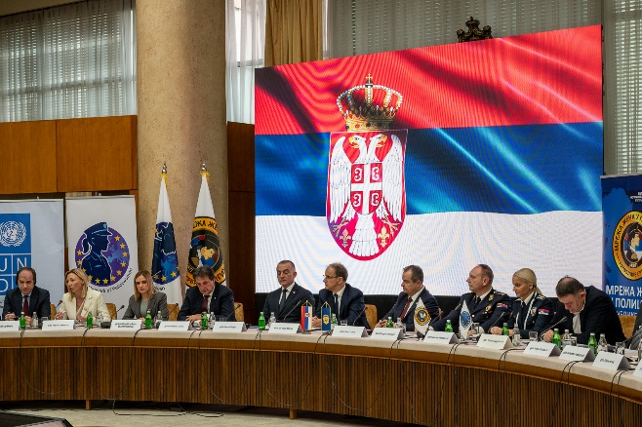
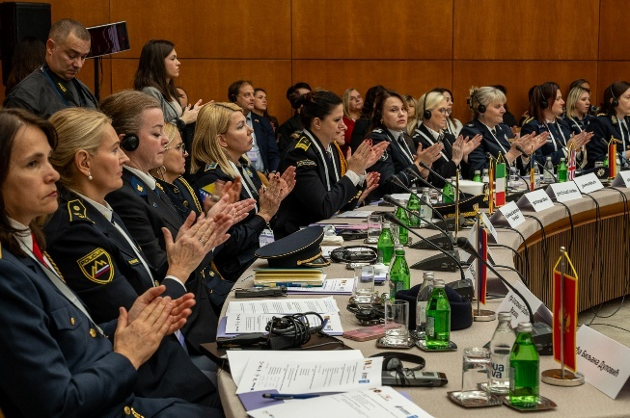
The more women push forward, the fewer women will wonder if they belong here.
Sophie Wallicky
Provincial Police Directorate ViennaDepartment of Organisation, Strategy and Service Execution
photo credit: undp serbia

The quote, “you can’t be what you can’t see” is very true. Women in positions of leadership have a unique opportunity, a duty some might say, to inspire and enable those talented women coming behind them.
Karen Duckworth
President Section UK – International Police Association
Former Chief Inspector – Metropolitan Police, London, United Kingdom

Activity 1.2.2: Continued support to associations of women police officials in Bosnia and Herzegovina and Serbia facilitating regional experience exchange and networking around the topic of SALW misuse prevention (joint activity of UNDP CO Serbia and UNDP CO BiH)
- Regional cooperation between women police networks from Serbia and Bosnia and Herzegovina was strengthened through the implementation of the third bilateral meeting of women police networks from Serbia and Bosnia and Herzegovina, held on 29 September – 1 October 2025 in Neum, bringing together 26 participants (all women) to exchange experiences on gender equality initiatives, women’s participation in the security sector and SALW misuse prevention. The meeting facilitated knowledge exchange on gender equality programmes in policing, including presentations on the Gender Coaching programme implemented by the Network of Women in the Police of Serbia and the Gender Equality Seal initiative within the Ministry of Security of Bosnia and Herzegovina. Furthermore, this networking meeting strengthened capacity and leadership of women police networks through a practical session on assertiveness in police work and discussions on integrating gender perspectives and SALW-related topics into the activities of women police associations.
- Regional networking and experience exchange was continued through active participation of representatives of women police networks from Bosnia and Herzegovina in the 4th Annual Conference of Women in the Police of Serbia in Belgrade.
3. Difficulties encountered, and measures taken to overcome the problems
- Meetings envisaged for the first half of the year were postponed, as requested by the Network of Women in the Police of Serbia, due to the number of women police officers-network members who are engaged in securing protests, which affected the dynamics of meeting implementation.

4. Changes introduced in implementation
- Meeting envisaged for first half of the year were postponed and implemented in the second half of 2025.

5. Achievements
- Strengthened position, visibility, and influence of the Serbian Network of Women in the Police, through support to the 4th Annual Conference of Women in the Police of Serbia, gathering 127 participants from 18 jurisdictions alongside senior national leaders and international partners, positioning the network as a key national and regional platform for dialogue on gender-responsive security and SALW control. By chairing and hosting two meetings of the European Network of Policewomen in Belgrade, the Serbian network reinforced its leadership role in regional cooperation, contributed to shaping strategic priorities, and expanded its influence beyond the national framework.
- Strengthened regional cooperation between women police networks from Serbia and Bosnia and Herzegovina through joint planning and implementation of networking and knowledge-exchange meeting, coordinated by United Nations Development Programme country offices in both countries.

6. Work plan for Q1 2026

Planned activities | Indicators | Budget (US$)
1.Planning and implementation of capacity building/advocacy activities of the Network of Women in the Police of Serbia.  2. Continued planning and implementation of activities fostering networking of women police officers in Bosnia and Herzegovina and Serbia and facilitating regional experience exchange and networking around the topic of SALW misuse prevention | 1.No of women police officers, including members of the Network of Women in the Police capacitated to participate in the development, advocacy and implementation of gender-responsive SALW control policies  2.Improved regional experience exchange and networking of the women police officials in Serbia and Bosnia and Herzegovina on gender mainstreaming in SALW control policies and SALW control. | $ 80,141.89

Output 2.1: | Conditions ensured for improved detection of potential firearms misuse for domestic violence and suicides and comprehensive prevention support
Total budget: | $275,000 | Spent:$156,272.71 | Balance: $ 118,727.29

1. Progress towards the output
The project works to improve the health system's ability to identify individuals at risk of firearm misuse and to collaborate with other institutions, particularly the police and public prosecutor’s offices, to manage cases of domestic violence reported by the health system while ensuring the safety of the victims. The project works to provide recommendations for the new Rulebook on determining natural persons' ability to hold and carry weapons within the healthcare system, by mapping obstacles and developing recommendations with healthcare workers in a collaborative process, as well as communicating perceived deficiencies and recommendations to relevant ministries. The project also enables learning and exchange of knowledge of professionals working on the cases of domestic violence and those working on security vetting to reduce the risk of firearms misuse among legal firearms owners.

During the reporting period, the project advanced efforts to strengthen the role of the healthcare system in identifying and responding to risks of firearms misuse, particularly in the context of domestic violence and suicide prevention. A specialized training resource for healthcare professionals was completed, and a risk-assessment tool was prepared and is ready for piloting to support medical evaluations related to firearm licensing. The project also facilitated knowledge exchange and capacity building among professionals from the police to improve risk assessment and coordinated responses to domestic violence cases involving firearm, reaching 261 participants (67 women and 194 men) from over 40 municipalities. In parallel, community-level interventions implemented by 4 project-supported civil society organizations contributed to increased awareness of 390 women on firearms-misuse risks, survivor support to 140 women and strengthened cooperation between institutions and local actors in preventing firearm-enabled violence against women.

2. Description of activities implemented during the reporting period

Activity 2.1.1: Improving healthcare workers’ capacity to identify risks and effectively implement procedures for reporting and addressing suspected risk of firearms misuse.
- In the reporting period, the project continued the development of a full training curriculum and supporting training materials, tailored to the operational realities and challenges faced by healthcare workers when detecting and reporting risks associated with firearms misuse. The program is being quality reviewed by the Batut Institute before its official publishing. Once approved by Batut, the training will be accredited as part of the continuous professional education system, to ensure institutional recognition and long-term sustainability.
To ensure continuous in-system knowledge dissemination, the program will be introduced through a Training of Trainers for healthcare professionals, aimed at strengthening their capacity to identify and respond to risks of firearms misuse related to violence and suicide in everyday clinical practice and enable them for further transfer of knowledge tailored to specific needs of different healthcare institutions. Mapping of healthcare institutions and professionals was implemented in collaboration with Batut institute to identify participants and partner institutions for the implementation of the Training of Trainers program.
Activity 2.1.2: Preparation of recommendations for the new Rulebook on determining natural persons' ability to hold and carry weapons within the healthcare system

- During the reporting period, efforts were continued to enhance medical evaluation resources within the healthcare system and strengthen the capacity of healthcare professionals in preventing and addressing domestic violence involving firearms misuse. A standardized risk assessment pilot tool was developed (format, scoring method, intended users and usage cases) for healthcare professionals when conducting medical assessments for firearm license applicants. The tool takes into consideration validated risk indicators, particularly those linked to mental health, domestic violence, as well as behavioral concerns identified in published works, and is aligned with Serbia’s legal framework.
The tool development is progressing through wide participation involving different stakeholders forming an advisory group to the process, involving representatives of the Autonomous Women’s Center NGO, Center for Applied Psychology, Institute of Public Health of Serbia "Dr Milan Jovanović Batut", Clinic for Psychiatric Disorders “Dr Laza Lazarević”, Ministry of Health, Ministry of Interior (Department for Psychological Activities), Ministry of Justice (Directorate for the Execution of Criminal Sanctions) and Republic Institute for Social Protection. While the instrument is intended for use in healthcare, its development requires testing across complementary systems that work directly with perpetrators of domestic violence. Through consultations with and feedback collected from this group, the tool’s testing approach and future application will be defined, serving also to foster ownership and ensure concrete institutional implementation. The results received from the piloting will be used to refine and validate the tool for use in healthcare settings.
Activity 2.1.3: Organize exchange of knowledge, dialogue and learning on the implementation of gender-responsive security vetting and reporting of firearms license holders to prevent misuse of firearms in domestic violence context
- In the reporting period, with the project’s support, the Criminal Police Directorate – Crime Suppression Service - Department for the Suppression of Homicide and Sexual Offenses and Domestic Violence, organized seven one-day trainings titled “First Line of Protection – Police Risk Assessment in Cases of Domestic Violence.” The aim of the trainings was to improve the understanding of the process of risk assessment and risk management related to domestic violence, and to contribute to a higher-quality institutional response to domestic violence, with the goal of timely prevention of the most severe outcomes, including loss of life. The training was conducted covering all police administrations in the territory of the Autonomous Province of Vojvodina. A total of 261 participants (67 women and 194 men) from 42 municipalities took part in the trainings. Police officers were introduced to all steps in handling cases, from the detection or reporting of violence, with particular emphasis on the challenges they face in practice. They also analyzed cases inspired by real-life events, with the aim of reviewing procedures and improving skills in assessing risks related to domestic violence, as well as in decision-making based on risk assessment in police work. A specific part of the training was dedicated to recognizing the risk of firearms abuse, bearing in mind the potential severe consequences for victims of violence as well as for responding officers. The trainings were implemented by experts from MoI and Judicial Academy, with in-depth knowledge on challenges that officers face in the field and they remain a source of support to local professionals upon training completion. The trainings were praised by participants for the numerous practical examples provided and opportunities for interactive work, along with a recommendation that such trainings be conducted more frequently. Through this activity, the project directly addressed the need to strengthen the practice of risk assessment and victim protection measures specifically in this region, given that in 2024 the Vojvodina region recorded 8 femicides in a family or intimate-partner context (which accounts for 47% of cases at the national level for that year).
"Every training renews my sense that my work is not in vain, because over time a person can grow tired."
training participant
"We need more frequent basic training on preventing domestic violence. There are few of us doing this—if there were more, the quality would be higher."
training participant

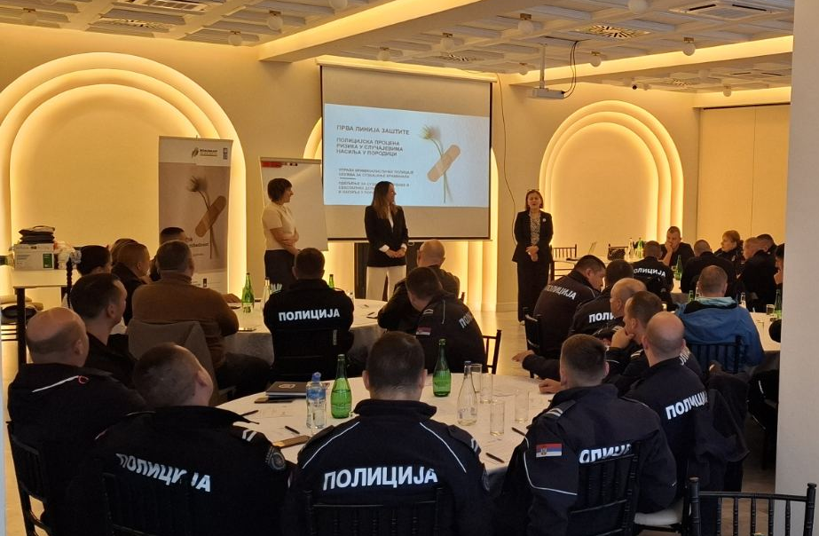
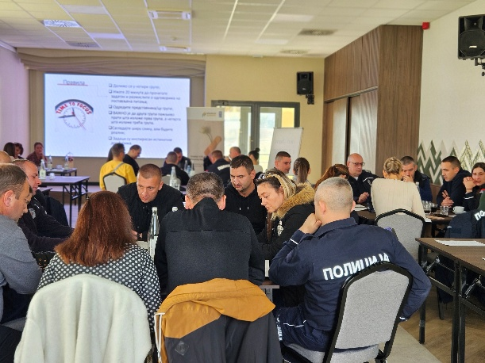
photo credit: undp serbia
- To strengthen the work of women’s organizations in the community and improve their collaboration with institutions, the project continued supporting activities of 4 local women’s organizations aimed at improving the protection of women from violence committed with firearms. The organizations were selected in 2024, based on the public call for financing projects of civil society organizations. The supported activities were implemented by August 2025. During the implementation period, grantees were provided with information on administrative and financial aspects of project implementation, reporting and visibility requirements, to ensure smooth implementation of activities and maximization of impact.
The organizations’ main activities and results included:
- Organization name: Women’s Center Uzice
Project title: Let’s Recognize Firearm Misuse Risks on Time
Implementation period: September 2024 – July 2025
To strengthen community multi-stakeholder cooperation in preventing domestic violence and femicides and improve understanding on firearms-enabled violence against women, two meetings and roundtable were organized with 33 participants (28 women and 5 men) from the police, prosecution, social and healthcare sectors. Additionally, 22 women, including those with multiple vulnerabilities, were trained to recognize signs of firearms misuse risks and take necessary safety steps. A basis for further policy advocacy was achieved by mapping available police data for the Zlatibor District on firearms misuse for domestic violence and femicides, with recommendations on more effective firearms misuse prevention. Interviews with 40 women survivors of violence helped to identify how firearm possession impacts their safety, reporting behavior, and access to protection. The findings revealed that 60% of interviewed women believe firearm possession restrictions would significantly reduce the risk of lethal violence. An awareness raising campaign was organized on social media, amplified by a TV talk show and podcast dedicated to violence prevention (including both participation of NGO and local MoI representatives), and street action (where informative fliers were disseminated to 300 citizens), all aimed at raising public awareness about gender-based violence and the risks of firearm misuse.

- Organization name: Human Rights Committee Vranje
Project title: Preventing Firearms Misuse in Domestic and Intimate Partner Violence and Enhancing Safety in the Pcinj District
Implementation period: September 2024 – June 2025

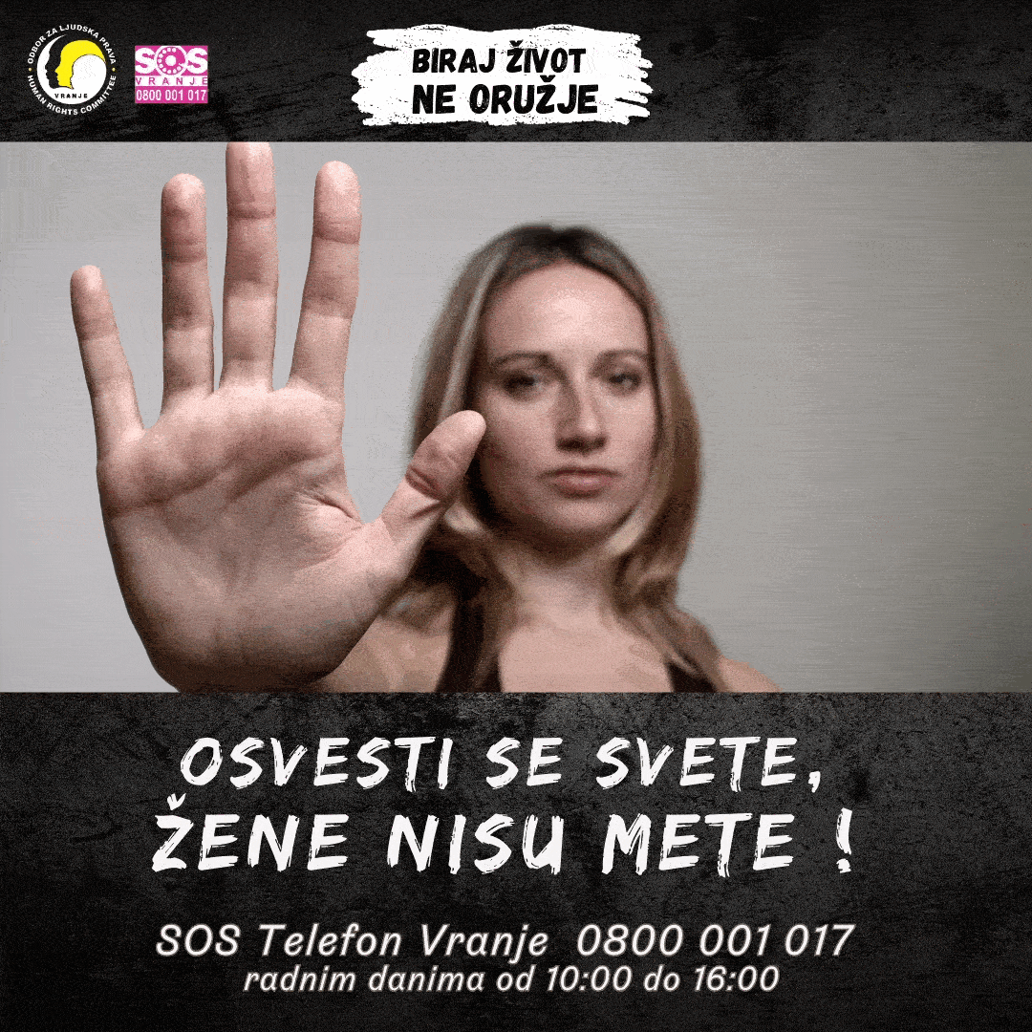
The project provided specialized SOS helpline support for women in the Municipality of Vranje, including information on firearms misuse risk and safety. The helpline received a total of 573 calls from 81 women, including 35 new beneficiaries, providing psychosocial support and information on firearm-related risks. To empower women with knowledge on recognizing and preventing gender-based and firearm-enabled violence, the organization conducted workshops across 6 South - Serbian municipalities and rural settlements, gathering 148 women participants. Three workshops for institutional representatives brought together 54 participants (44 women and 10 men) to improve multi-agency prevention of firearms misuse in domestic violence cases, strengthening the organization’s presence in the local violence prevention environment. Awareness-raising activities reached wide audiences through thematic online banners (viewed over 3 million times), and the distribution of 400 posters and informational leaflets across public locations. To guide coordinated local action against firearm-enabled gender-based violence the organization developed an analytical report titled “Three Communities – One Threat: Response to Femicide in the Pčinj District,” summarizing available data and lessons learned in prevention work. Outreach to 15 journalists (8 men and 7 women) promoted responsible media reporting on femicide prevention.
image credit: human rights committee vranje

- Organization name: Zrenjanin Educational Center
Project title: Preventing firearms misuse in cases of domestic violence in rural Banat communities
Implementation period: September 2024 – August 2025
The project empowered rural women’s associations to become key actors in preventing firearm-enabled gender-based violence. Eight workshops and meetings engaged a total of 167 participants (166 women and 1 man) from rural settlements of the Vojvodina province. These sessions strengthened participants’ understanding of the risks of firearm possession in domestic settings, improved their knowledge of reporting procedures and legal protections, and built confidence for women to act as focal points for awareness and support in their communities. The organization also produced 1,200 multilingual leaflets and 200 infographics in Serbian, Hungarian, Romani, and Romanian to disseminate practical information on firearms misuse and available support services. The initiative included three public debates, bringing together women’s associations, police, prosecutors, and social welfare representatives (56 women and 2 men) to promote multisectoral collaboration. These exchanges marked an important step toward building trust between institutions and rural communities and demonstrated that coordinated local responses are key to reducing the risks of firearms misuse in domestic violence cases.

In rural areas, women's associations are a great resource. The community should support victims, and associations play an important role in that.
participant of meeting with local institutions

- Organization name: Association of women’s non-governmental organizations “Women against Violence Network”
Project title: A Firearm in the House is Not a Trophy but a Danger
Implementation period: September 2024 – May 2025
The Network’s SOS helpline responded to a total of 150 calls from 63 women seeking psychological support, legal information, or institutional referrals. The helpline’s work directly contributed to increased safety, as one reported firearm threat led to timely police intervention and weapon confiscation. Capacity building was a strong project component: 15 consultants completed accredited training in providing social services to victims and received training on the Law on Free Legal Aid and Law on Prevention of Domestic Violence. In total, four workshops were held, each in different (mostly rural) locations, reaching 57 women and raising awareness on firearm-related risks, femicide prevention, and safe reporting. Awareness efforts were amplified through a leaflet distribution campaign (500 copies) and a press conference in Belgrade, where project results and lessons were shared on preventing firearm misuse in domestic and intimate partner violence.
3.Difficulties encountered, and measures taken to overcome the problems
- Supported NGOs reported delays in activity implementation due to hindered communication with institutions and related to the current socio-political situation in the country. Two NGOs were granted non-additional-funding extension to complete envisaged activities.

4. Changes introduced in implementation
- No changes introduced.

5. Achievements
- Contribution to strengthening healthcare system’s role in preventing firearms misuse by developing an accredited training framework and training-of-trainers approach that will enable healthcare professionals to systematically identify and report risks related to firearm-enabled violence.
- Contribution to Improved institutional capacity for risk-informed firearm licensing procedures through the development of a standardized risk assessment tool for medical evaluations, laying the groundwork for more consistent and evidence-based assessments of individuals’ eligibility to hold and carry firearms.
- Strengthened institutional responses to domestic violence cases involving firearms by improving 216 police officers’ capacity to conduct risk assessments and apply preventive measures, contributing to more effective protection of victims and early prevention of severe outcomes.
- Expanded community-level prevention and survivor support mechanisms through 4 civil society initiatives that increased awareness of firearm-related risks, strengthened local cooperation between institutions and communities, and improved access to psychosocial and legal support for women exposed to violence.

6. Work plan for Q1 2026
Planned activities | Indicators | Budget (US$)
1.Planning and implementation of Training of trainers (ToT) for healthcare workers on response to (firearms-enabled) domestic violence through multi-agency cooperation and provision of support to those in need.  2.Continued development of assessment tool and guide to support medical evaluations within the healthcare system with a view of preventing firearms misuse  3. Planning and Implementation of MoI prevention activities related to domestic violence | 1. No. of healthcare professionals trained to identify risks and effectively implement procedures for reporting and addressing suspected risk of firearms related domestic violence  2. Recommendations for the new Rulebook on determining natural persons' ability to hold and carry weapons within healthcare system developed and validated by relevant entity  3. Number of standardized risk assessment tools for healthcare professionals developed and piloted and model for inter-institutional coordination finalized and disseminated.  4. Number of trained police officers on (firearms-misuse) risk assessment in domestic violence cases delivered. | $ 118,727.29

Output 2.2: | Information improved on the harmful effects of underlying practices and attitudes leading to firearms misuse and supportive mechanisms preventing suicides
Total budget: | $ 125,000 | Spent:  $ 58,322.62 | Balance: $ 66,677.38

1. Progress towards the output
Bearing in mind the social context in which prejudice and stigma prevent people from seeking help in case of mental health problems, which then may lead to firearms misuse, the project supports the MoI’s preventive activities, aligned with the Ministry’s identified needs, and provides support in activities aiming to improve communication with citizens, especially through media and media activities. The project also supports the activities of the MoI Department of Psychological Activities to reduce negative consequences of professional trauma, including those affecting mental health, experienced by professionals involved in violent events with firearms. Additionally, through cooperation with the healthcare and civil sector, the project focuses support to change mindsets and debunk prejudices that prevent men from seeking mental health support, to deter the misuse of firearms for violence and suicide.

Progress towards the output was reflected in strengthened institutional capacities and expanded outreach to prevent firearm misuse through both systemic and community-based approaches. The project enhanced the Ministry of Interior’s ability to communicate effectively with citizens and promote safe reporting through a nationwide awareness raising campaign. Additionally, Moi improved psychosocial support mechanisms for police officers exposed to firearm-related trauma, through regional experience exchange gathering 58 police psychologists. At the same time, targeted awareness-raising and pilot training activities for 11 army veterans contributed to reducing stigma around mental health and encouraging help-seeking among high-risk groups, particularly men with access to firearms. Adaptive implementation, including the shift toward healthcare-based capacity building, further ensured sustainability and broader impact in preventing firearm-related violence and suicide.

2. Description of activities implemented during the reporting period

Activity 2.2.1. – Support MoI communication activities to prevent firearm misuse in the community and domestic violence context

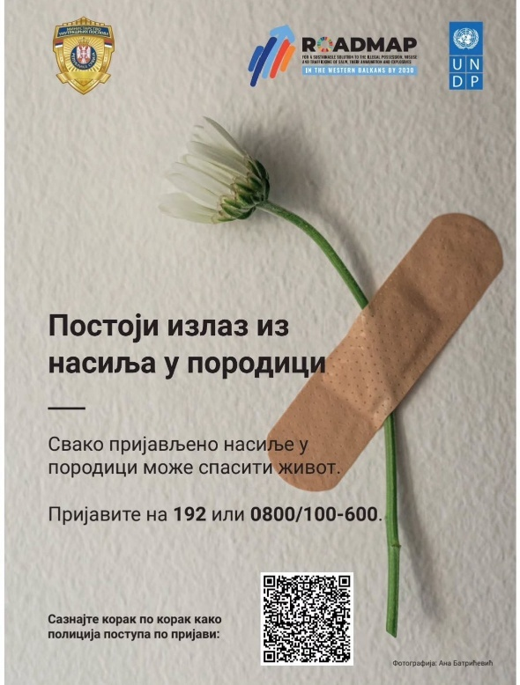
- Building on long-standing cooperation, the project significantly strengthened institutional capacity and public trust in reporting mechanisms for domestic violence by supporting and amplifying MoI-led awareness efforts during the global 16 Days of Activism campaign. Through a strategically designed visual communication campaign, the project contributed to improved access to clear, actionable information for victims, directly supporting higher reporting readiness and confidence in police response.
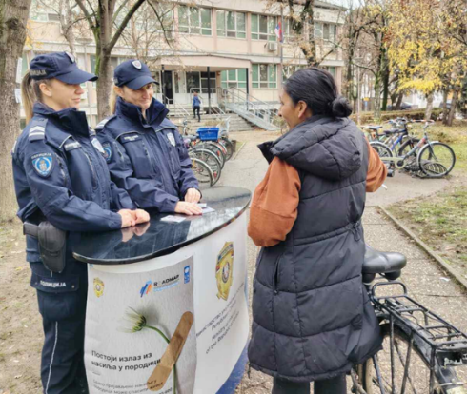
The production and nationwide distribution of 1,000 posters and 20,000 pocket calendars, each featuring a clear call to report violence and a QR code linking to a practical guidance brochure, enhanced outreach to at-risk populations and ensured consistent, user-centered messaging. By promoting a previously developed project-supported information resource hosted on the MoI website, the intervention reinforced continuity, sustainability, and long-term public access to reliable information on safe reporting of violence and victim protection procedures.
PHOTO CREDIT: MINISTRY OF INTERIOR

Systematic dissemination across police stations and high-frequency public service points, combined with integration into MoI’s independently planned and implemented nationwide outreach activities, contributed to increased visibility of institutional support services and reinforced the message that domestic violence is unacceptable and reportable. At the local level, public outreach actions, including billboards, public transport messaging, and direct engagement through community policing initiatives, were led by local police officers demonstrated a multiplier effect, expanding reach and fostering dialogue between citizens and law enforcement. Crucially, the initiative reflects strengthened institutional ownership and the embedding of awareness-raising practices within MoI operations, showing that long-term cooperation has built the understanding and capacity for the Ministry to sustain and carry forward such efforts beyond the project lifecycle.
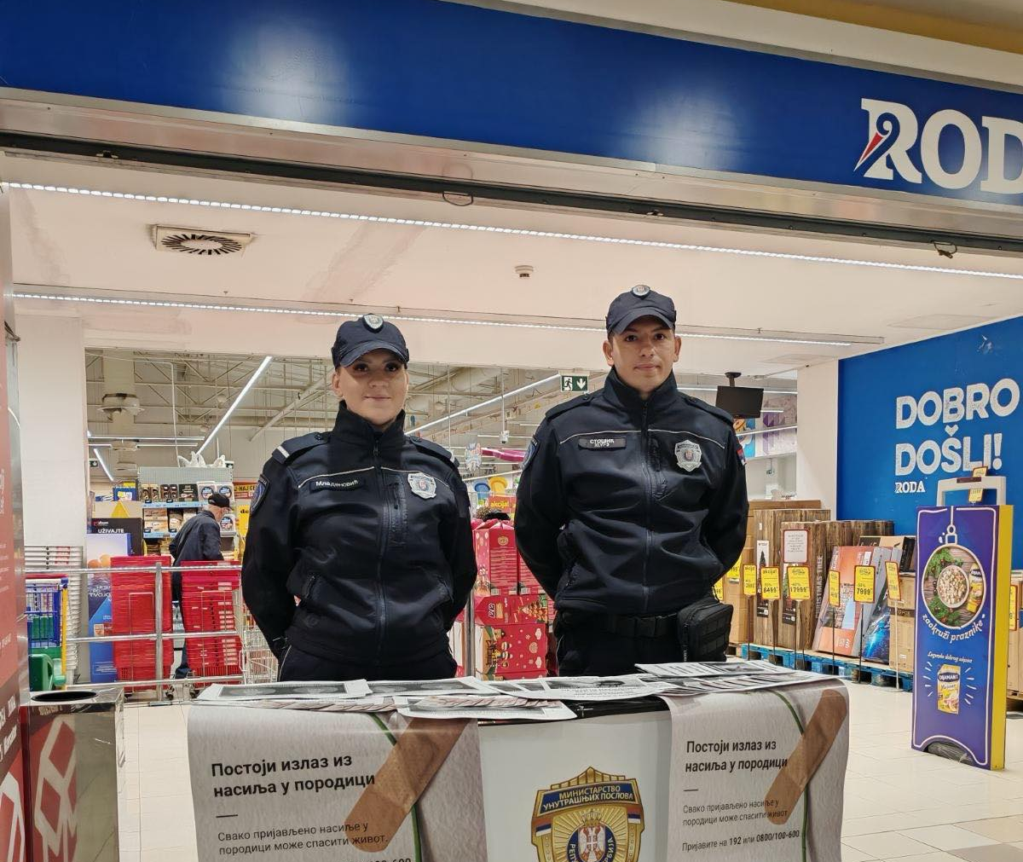
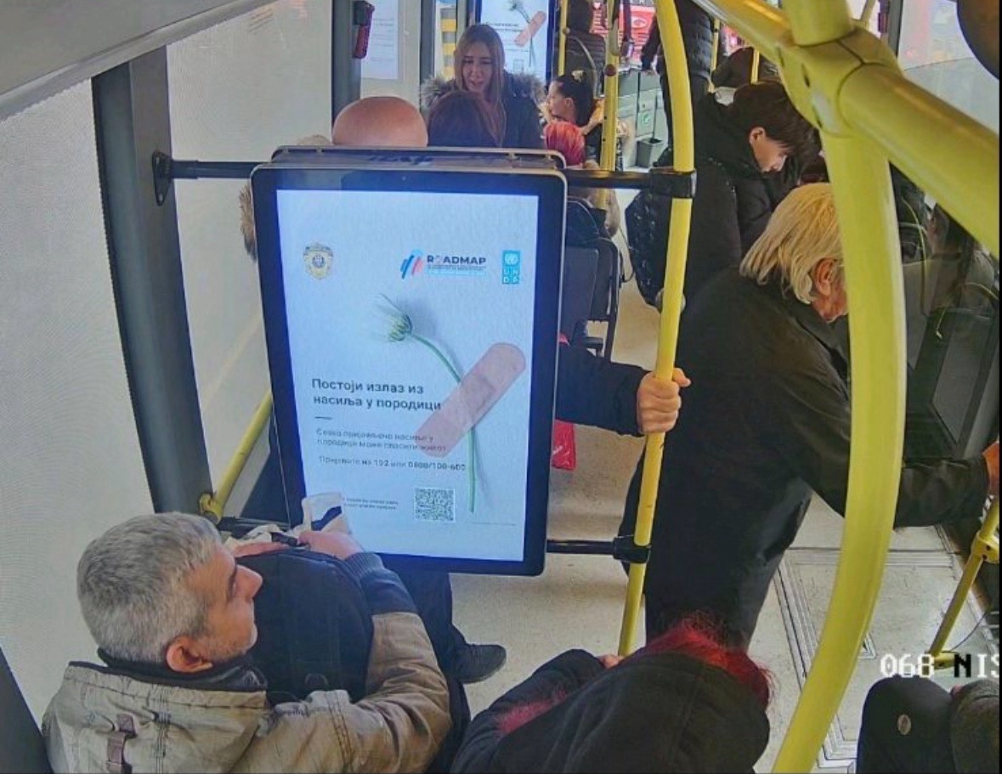
photo credit: ministry of interior

Activity 2.2.2 – Support to institutional capacity building and implementation of activities to prevent firearms misuse for domestic violence and suicides among police officers
- With the project’s support, the MoI strengthened the institutional capacities for mental health support and suicide prevention within the police service through the organization of a two-day expert meeting in Belgrade on 9–10 October 2025. Convened by the MoI Department of Psychological Activities, the event contributed to enhancing the quality, coordination, and sustainability of psychosocial support systems for police officers, an important component of increasing overall safety and resilience within the institution.
The first day facilitated regional knowledge exchange among 58 police psychologists (53 women and 5 men) from five jurisdictions, enabling the sharing of good practices in suicide prevention and advancing alignment of psychosocial support approaches across the region. This contributed to improved professional competencies and fostered cross-border cooperation in addressing mental health risks within police services.
The second day strengthened national-level multi-sectoral cooperation by connecting 31 Serbian police psychologists (30 women and 1 man) with specialized civil society organizations providing support to individuals in psychological crisis. This engagement expanded awareness of available external support mechanisms and promoted more integrated and responsive referral pathways.
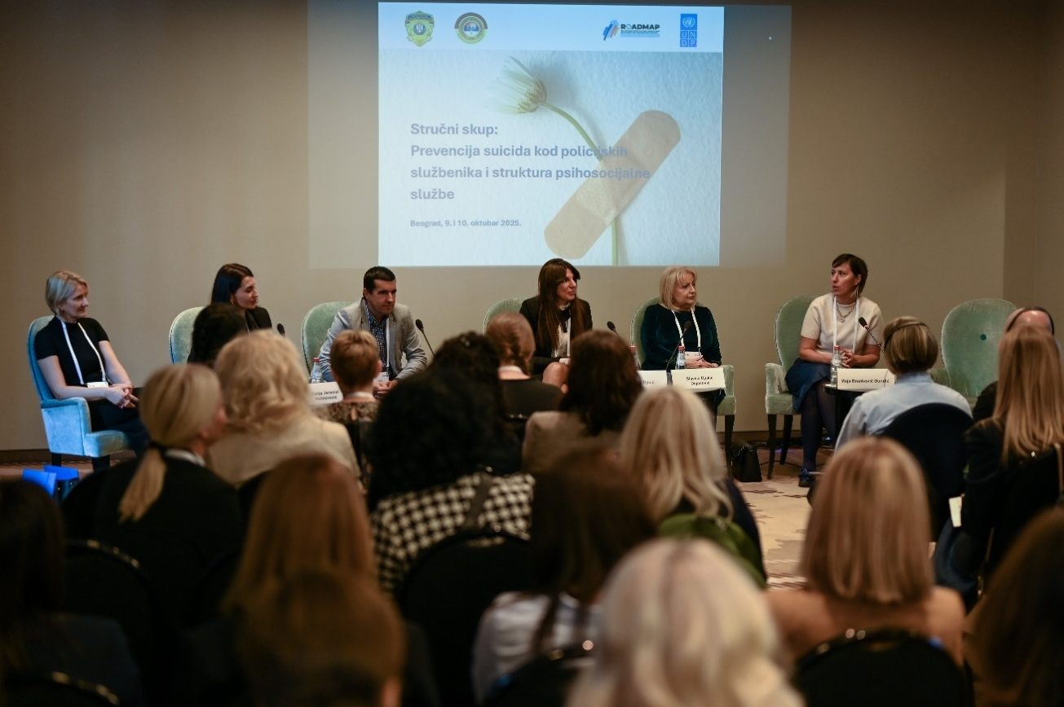
Activity 2.2.3: Support to learning and community-based activities to prevent firearms misuse for suicide
photo credit: undp serbia
- In the reporting period, a one-day training curriculum on prevention of firearm misuse for suicide was developed in collaboration with the SRCE Centre specializing in support to persons in crisis The curriculum was developed based on a comprehensive needs assessment and stakeholder mapping exercise, and it laid the foundation for scalable and sustainable capacity-building interventions. The curriculum was used to deliver targeted training to 11 members (all men) of the Association of Army Veterans on 14 June 2025, thus improving their ability to recognize suicide risks, as well as risks connected to firearms misuse, respond to psychological crisis situations, and promote safe behaviors among peers, contributing to community-level prevention efforts.
The topics we discussed here show just how alienated we have become. And talking and coming together is higly needed. It’s always easier to talk more openly about these things during gatherings such as this one, which are less formal and more relaxed.
Training participant
a
I helped three of my colleagues and I told them I will always be there to listen to them. I need to hear them, in order to know how to help.
Training participant

What we lack is a community which will act as a protective factor and that will start dealing with this problem. Training participant

- Awareness-raising tools (posters and leaflets) were developed and disseminated to training participants and online, targeting men over 45, identified as a high-risk group, providing practical guidance, challenging stigma, and promoting help-seeking. Key messages on risks of firearm misuse and available support services were shared through UNDP’s social media platforms, including marking International Day of Suicide Prevention.
- Training of Trainers programme is developed for healthcare professionals, combining institutional and NGO expertise, supporting long-term, system-wide capacity to address (firearms-enabled) suicide risks.
Cooperation with the SRCE Centre enabled the introduction of tailored approaches for high-risk groups, as well as integration of expert knowledge on psychosocial support and suicide prevention.
3.Difficulties encountered, and measures taken to overcome the problems
- In response to limited feasibility of community-based trainings, the project redirected efforts toward strengthening systemic approaches within the healthcare sector.
4.Changes introduced in implementation
- In stead of further community workshops, ToT program for healthcare professionals is being developed to support long-term, health system capacities to address (firearms enabled) suicide risk and effectively implement prevention measures.

5. Achievements
- Strengthened national prevention efforts through amplification of the Ministry of Interior’s community outreach on preventing domestic violence (including that through firearms misuse), increasing public awareness and encouraging safe reporting, through widely distributed, victim-centered communication materials. MoI’s independent nationwide outreach action during the “16 Days of Activism” campaign, which was planned, resourced, and delivered by MoI engaging community-based police officers, demonstrates the tangible ripple effect of UNDP’s long-standing cooperation, as well as training and sustained awareness raising efforts with MoI, through the project phases. This independent nationwide outreach initiative translates prior joint work into institutional ownership and continued action to encourage safe reporting of domestic violence.
- Institutional capacity within the police was enhanced through regional and national expert exchanges gathering 89 police psychologists (83 women and 6 men), that reinforced suicide prevention practices and psychosocial support systems for police officers, a group at heightened occupational risk.
- The project contributed to initiating a stigma-free community support system, by enabling representatives of high-risk groups (11 army veterans) to better understand risks associated with access to firearms and equipping them with knowledge and skills in responding to situations involving suicidal behavior, leveraging the power of peer connection.
- To further support reducing stigma and promoting early help-seeking, communication messages were defined, and a knowledge material was created and disseminated to encourage individuals in psychological crises to seek support and to guide bystanders in recognizing and responding to the risk of firearms-enabled suicide.

6. Work plan for Q1 2026
Planned activities | Indicators | Budget
- Preparations for training of trainers for suicide prevention through the healthcare system | 1.Development of a training curriculum, as well as the training of trainers, aimed at strengthening healthcare system capacities to identify and support individuals at risk of suicide. | $ 66,677.38

Output 2.3: | Best practice sharing enabled with professionals, media and academia on effective mechanisms for prevention of future firearms related incidents
Total budget: | $ 174,000 | Spent: $ 71,343.13 | Balance: $ 102,656.87

- Progress towards the output
The project focuses on learning from mass shootings and similar firearms-related incidents that have occurred internationally, and the response provided, to help facilitate healing and contribute to more effective prevention of future occurrences. It works to map effective practices that have been implemented in jurisdictions with a similar context, aimed at building capacities for greater readiness for future similar incidents, including mental health recovery of those affected by mass shootings. Based on the identified good practice, the project will implement a training program and follow-up support for mental health professionals in Serbia, enabling them to provide mental health services to those affected by mass shootings. The project also envisages continued support to the group Journalists against Violence (supported by UNDP since 2017) in its efforts to promote learning and partnerships that lead to ethical and preventative media coverage of incidents involving SALW. The project supports the group to analyze media reporting on firearms-related incidents in the context of domestic violence and mass shootings to identify violation of the media code of ethics and propose alternative reporting methods that contribute to prevention. Besides training for selected media and gatherings for journalists, the project will also support exchange of specialist knowledge with a European media hub.

Progress towards this output involved strengthened knowledge exchange and application of international best practices across mental health and media sectors to improve prevention and response to firearms-related incidents. Capacity of mental health professionals was enhanced through sustained supervisory support of previously trained mental health professionals, enabling the provision of trauma-informed care to individuals affected by mass shootings, particularly youth. At the same time, cooperation with the Journalists against Violence advanced evidence-based analysis of media reporting, laying the groundwork for developing practical guidance on ethical, trauma-informed coverage of mass shooting incidents that contributes to prevention and recovery.

2. Description of activities implemented during the reporting period

Activity 2.3.1: Identification of international best practices on post-tragedy/mass shooting community reintegration and improved mass shooting prevention
- In the reporting period, follow-up support was provided to the previously 31 mental health professionals (24 women and 7 men) trained to provide Trauma-Focused Cognitive Behavioral Therapy for children, adolescents and families who are direct or indirect victims of mass shootings. The follow – up support was provided by the Norwegian experts, who also performed the training. It involved monthly group-based online supervision sessions which helped guide therapists. These sessions continued through a one-year period (starting from October 2024 when the training was delivered). This support was provided to ensure the effective and sustained implementation of therapy work addressing psychological needs arising from firearm-related violence and trauma. This is the project’s direct contribution to systematic approaches to healing following the May 2023 mass shootings and for providing trauma-focused assistance to those affected, including youth in crisis.
Activity 2.3.2: Continued support to the group Journalists against Violence in its efforts to mobilize national and regional media and promote learning and partnerships that leads to ethical and preventative media coverage of incidents involving SALW
- With the project’s support and in close consultations with the Multidisciplinary team for establishing a Memorial center in remembrance of victims of the mass murders in the “Vladislav Ribnikar” Elementary School in Belgrade (MD team), the group “Journalists against Violence” developed their methodology for the analysis of media reporting on the May 2023 mass shootings, and mapped the dominant narratives on the incidents. Besides the principles of trauma-informed reporting, the methodology is also based on and aligned with findings of the Analysis of Media Reporting on Firearms Misuse in Male Gender-based Violence Against Women in the Western Balkans (UNDP SEESAC, 2024). Based on the defined sample of reports to be analyzed, press clippings from the press, electronic and web media were obtained as the basis of the analysis, while a team of 11 journalists was trained (11 September 2025) to perform the analysis, which is in progress. Once ready, the analysis findings will be complemented with direct feedback from affected families regarding their attitudes of media coverage of the mass shooting events, to ensure that recommendations reflect needs and views of those directly affected by events and media reporting on them. To complement the analysis, an analytical report on visual elements of media reports was drafted, inclusive of feedback collected from photographers and photo-reporters on their in-the-field experiences and perceptions on ethical and trauma-informed visual depiction of mass shootings for media reports.

3. Difficulties encountered, and measures taken to overcome the problems
- No difficulties encountered.
4. Changes introduced in implementation
- No difficulties encountered.
5. Achievements
- Strengthened national trauma response capacity through sustained, expert-led supervision of mental health professionals trained in Trauma-Focused Cognitive Behavioral Therapy for children, adolescents, and families affected by mass shootings. The follow-up support provided ensures the effective, ethical, and lasting application of evidence-based trauma care in Serbia, particularly in response to the May 2023 mass shootings.
- Contribution to trauma-informed, ethical media practices by supporting the Journalists against Violence group to train 11 women journalists who started conducting an analysis of media reporting on the May 2023 mass shootings, based on developed methodology and indicators. The analysis findings will inform the development of journalist guidelines that prioritize dignity, accuracy, and prevention-focused reporting in the aftermath of firearms-related incidents.

6. Work plan for Q1 2026
Planned activities | Indicators | Budget (US$)
1.Planning of further follow-up support to trained professionals of the Institute for Mental Health  2. Continued implementation of analysis of media reporting on mass shootings and SALW misuse, training and networking of journalists and photo-reporters to improve ethical media reporting on violence against women involving firearms misuse | 1.International best practices on post-tragedy/mass shooting community reintegration mapped and shared with professionals, media and academia  2.Number of journalists with increased capacities and networking opportunities to engage in preventive and ethical reporting on firearms-enabled gender - based violence, including mass shootings | $ 102,656.87

V. Monitoring and Evaluation of activities (for Annual and Final Reports only)
During the reporting period, all activities involving work in the field (e.g. trainings, meetings, conferences) were monitored through on-site visits. In addition to this, regular administrative records (participant lists, meeting minutes and reports) and photo documentation was made for all activities involving work with stakeholders. Beneficiaries’ feedback was also collected to gain insight into the effectiveness of activities and further needs. Briefing and de-briefing meetings with project partners were held regularly to facilitate identification of topics of relevance, adjustment of activities to needs of specific target groups and to address future needs – e.g. for meetings of representatives of networks of women in the police.
Trainings with police representatives were evaluated through questionnaires completed by training participants. These showed that the trainings were highly relevant, as the trainings received an average score of 4.66 for relevance (with 1 being the lowest and 5 being the highest mark), as well as an average mark of 4.1 for the applicability of acquired knowledge in practice. The main suggestions of police professionals who participated in training activities were to ensure that such trainings are held more frequently and to continue with practical consideration of the problem through case studies. Furthermore, several participants pointed out the need to invite professionals from the judiciary and social protection system to these trainings as well, to contribute to multi-agency cooperation in addressing firearms-enabled violence. As the trainings were planned jointly with the MoI, its representatives were directly involved in the trainings as lecturers, and were also able to monitor participant responses, as well as to provide expert insights, and they also remained a source of support to the participants upon training completion.
After the completion of activities within this reporting period, the UNDP project team held a briefing to track progress, identify lessons learned and space to improve project delivery and alignment with beneficiaries’ expressed needs. This practice will continue until project closure, with a view of ensuring that a gender sensitive approach is maintained at all stages of the project, and that a gender-responsive approach is applied with regards to identification of opportunities of transformation of institutional practices, development of knowledge materials and awareness raising activities.

VI. Coordination with relevant stakeholders - Partnerships
Building on established cooperation, the project maintained close collaboration with key national institutions, civil society organizations, and international partners, while also initiating new partnerships to respond to emerging needs, particularly in the areas of mental health and post-crisis recovery.

The Ministry of Interior remained the project’s principal institutional partner, actively engaged in the design and implementation of activities across all outputs. This included joint efforts in improving administrative data systems, delivering police trainings, implementing nationwide awareness campaigns, and strengthening psychosocial support services. The MoI also demonstrated increased institutional ownership, independently leading outreach activities during the 16 Days of Activism campaign, reflecting the sustainability of long-term collaboration with UNDP.

Collaboration with the Network of Women in the Police of the Republic of Serbia was fortified, and the project will build upon the momentum gained in 2025 to further strengthen women’s engagement in SALW control policy making and increase visibility of activities and impact of both the Serbian and European networks gathering women in the police.
Partnerships with the Ministry of Justice and other judicial stakeholders were strengthened through the project’s direct contribution to the development of amendments to the Law on Prevention of Domestic Violence. Multi-sectoral consultations involving representatives from police, judiciary, and social welfare institutions ensured that project-supported recommendations were grounded in practice and integrated into national policy processes.

Cooperation with the Institute of Public Health of Serbia “Dr Milan Jovanović Batut” was deepened, particularly in the development of training programmes and tools for healthcare professionals. Partnership with “Batut” was additionally strengthened as the Institute invited UNDP project team members to participate in the working group developing a new protocol of action for health worker’s response in cases of gender-based violence against women and domestic violence, to align with the national general protocol of March 2024. This is an opportunity to integrate into the draft document lessons learnt and recommendations from the project, thus ensuring greater impact and sustainability of results. The continuing partnerships is central to institutionalizing risk detection and prevention of firearms misuse within the healthcare system.
At the same time, collaboration expanded to include a broader advisory group of stakeholders, such as the Clinic for Psychiatric Disorders “Dr Laza Lazarević”, the Republic Institute for Social Protection, the Autonomous Women’s Centre, supporting the development and ensuring ownership over the upcoming piloting of a standardized risk assessment tool.

The project also continued to closely cooperate with the Institute of Mental Health, ensuring sustained application of trauma-informed practices through follow-up supervision for trained professionals working with individuals affected by mass shootings. International expertise, particularly from Norwegian partners, remained instrumental in strengthening national capacities for trauma recovery.

Engagement with civil society was further expanded and diversified. Four local women’s organizations played a key role in delivering community-based prevention, survivor support, and awareness-raising activities, while also strengthening cooperation with local institutions. Collaboration with the Victimology Society of Serbia contributed to the development of evidence-based recommendations regarding needs of survivors and first-responders in crises situations, including mass shooting incidents, yielding direct insights into views of those directly affected by the May 2023 shootings and enabling UNDP to align its work with concrete needs of beneficiaries. In addition, partnership with the SRCE Centre specializing in suicide prevention, enabled the design and delivery of targeted suicide prevention interventions, particularly for high-risk groups, including men over 45 with access to firearms. The project also reinforced its long-standing cooperation with the Journalists against Violence group, advancing joint efforts to promote ethical, trauma-informed media reporting on firearms-related incidents.

Regional and international partnerships remained a key component of the project. Cooperation with UNDP Bosnia and Herzegovina enabled joint activities between women police networks, while engagement with the European Network of Policewomen positioned Serbia as an active contributor to regional dialogue on gender equality in the security sector.

Stakeholder In-kind support:
Project stakeholders provided valuable in-kind expert and logistical support illustrating ownership of project efforts and contributing to their greater impact.

MoI provided in-kind support in securing expert trainer for training implementation on risk assessment for police officers. This ensured that training participants received knowledge based on a deep understanding of practical, in-the-field policework and persisting challenges and how to overcome them. Furthermore, the trainer remained a source of support to participating police officers after the trainings, ensuring greater application of gained knowledge.

The Network of Women in the Police of the Republic of Serbia provided in-kind support in the organization of the network’s 4th annual conference, ensuring event premises, logistical support in preparation and implementation of the event, contributing to the event’s impact. This involved complex communication with contact officers from 18 jurisdictions, coordination of event participants, as well as planning activities – from content to ensuring all logistical details.

The “Batut” Institute provided in-kind support in ensuring premises for meetings and expert knowledge and information for development of ToT for healthcare professionals and mapping of potential training participants.

VII. Sustainability (for Annual and Final Reports only)
The sustainability of the project is strongly grounded in its systemic, institutional and capacity-building approach, which ensures that results achieved in 2025 will continue to generate impact beyond the project lifecycle.
At the institutional level, sustainability is reflected in the project’s continued close cooperation with key national stakeholders, particularly the Ministry of Interior and healthcare institutions. The ongoing integration of improved gender- and age-disaggregated data collection practices within the Ministry of Interior establishes a long-term foundation for evidence-based policymaking. By embedding new data frameworks into existing administrative systems, the project ensures that enhanced data collection and analysis will continue to inform policies and operational responses to firearm misuse, especially in the context of domestic violence.
The project’s contribution to legislative processes further reinforces sustainability. Evidence-based recommendations developed through multi-sectoral consultations have already informed amendments to the Law on the Prevention of Domestic Violence. This direct linkage between project outputs and national legal frameworks ensures that project results are institutionalized and continue to shape protection mechanisms, particularly regarding risks associated with firearm access.
Capacity-building efforts across sectors provide another critical pillar of sustainability. The development of accredited training programs for healthcare professionals, including the Training of Trainers model, ensures continuous knowledge transfer within the health system. The introduction of practical tools, such as the standardized risk assessment instrument for firearm licensing, further contributes to long-term impact. Once piloted and validated, this tool may become part of routine procedures ensuring consistent and evidence-based risk evaluation practices.
At the community level, the project has built sustainable prevention and support mechanisms by empowering civil society organizations and local actors. The strengthened capacities of women’s organizations, established referral pathways, and increased public awareness, particularly regarding firearm-related risks in domestic violence and suicide, will continue to contribute to early detection, reporting and prevention efforts.
Importantly, the project has promoted institutional ownership of key interventions. For example, awareness-raising activities led independently by the Ministry of Interior, as well as continued engagement in regional and international networks such as women police associations, demonstrate that stakeholders have adopted and internalized project approaches. This ownership ensures continuity of activities, including public outreach, professional networking and advocacy for gender-responsive security policies.
Finally, the project’s emphasis on knowledge generation and dissemination, including mapping of crisis-response systems, media analysis, and development of trauma-informed approaches, creates a lasting evidence base for future policy development, training and practice. These resources will continue to guide national efforts in preventing and responding to firearm-related violence, including mass shootings.

VII. Update on risks and mitigation measures (for Annual and Final Reports only)
While the project “Reduce Risk – Increase Safety” has demonstrated strong progress and institutional ownership, implementation has been affected by the broader socio-political context in the country. However, the project has proactively identified these risks and applied mitigation measures to ensure continuity, effectiveness and sustainability.
As observed during the reporting period, operational demands, such as the engagement of police officers in securing public events, led to delays in planned activities, particularly those involving trainings and networking. To mitigate this, the project applied a flexible implementation approach, rescheduling activities and maintaining continuous communication with partners to ensure alignment with institutional priorities and availability.
Another risk concerns inter-institutional coordination, which is essential for addressing complex issues such as firearm misuse in domestic violence and suicide prevention. Differences in mandates, procedures, and levels of capacity across sectors (police, healthcare, judiciary and social protection) may limit effective collaboration and data exchange. The project mitigates this risk by promoting structured multi-sectoral dialogue, for example in developing the joint risk assessment tool, and supporting platforms for regular communication, thereby strengthening coordination mechanisms over time.
Capacity-related risks are also present, particularly in ensuring consistent application of newly developed tools, methodologies and training programs. Without continuous reinforcement, there is a possibility that knowledge gained through trainings may not be systematically applied in practice. To address this, the project emphasizes institutionalization through accredited training programs, Training of Trainers models, and integration of tools into official procedures, ensuring that capacities are maintained and scaled within systems rather than remaining at the individual level.
A further risk involves sensitivity and resistance around topics such as gender-based violence, mental health and firearm control. Social stigma and entrenched attitudes may limit both institutional responsiveness and community-level engagement, particularly in encouraging reporting or help-seeking behaviors. The project mitigates this through sustained awareness-raising efforts, promotion of survivor-centered and trauma-informed approaches, and engagement with civil society organizations that have established trust within communities.
Technical and operational risks are also associated with the introduction of new systems and tools, such as risk assessment instruments. Challenges may arise in integrating these into existing workflows or ensuring their consistent use across institutions. To mitigate this, the project adopts a phased approach, including piloting, stakeholder consultations, and iterative refinement based on user feedback, ensuring that tools are practical, user-friendly and aligned with institutional capacities.
At the community level, risks include limited access to vulnerable or hard-to-reach groups, particularly in rural areas, as well as potential disruptions due to external factors. The project addresses this by partnering with local civil society organizations, which have direct access to communities and the ability to adapt outreach approaches to local contexts, thereby ensuring continuity and relevance of interventions.
Finally, there is a risk related to the sustainability of momentum after the project’s completion, particularly if continued resources or political commitment are not secured. This risk is mitigated through strong emphasis on institutional ownership, alignment with national policies and legal reforms, and embedding project outputs within existing systems and frameworks, ensuring that key interventions continue independently of project funding.
Overall, through adaptive management, strong partnerships and a focus on institutionalization, the project effectively minimizes risks and ensures steady progress toward its objective of reducing firearm-related risks and increasing safety.
An updated risk matrix is annexed to this report.

VIII. Lessons learnt (for Annual and Final Reports only)
The implementation of the project in 2025 has provided valuable insights into both the successes and challenges of advancing firearm risk reduction, gender-sensitive policies, and trauma-informed approaches in Serbia. Key lessons learned to support ongoing learning, knowledge sharing, and improvements for future programming include:

Key Project Successes and Supporting Factors

Whole-of-System Approach: The project successfully engaged actors across all levels, from first-line responders to policymakers, facilitating comprehensive, evidence-based reforms in firearm risk management and violence prevention.

Regional Knowledge Exchange: Strong regional networks of police psychologists and women police associations fostered collaboration, experience-sharing, and capacity building.

Women’s Leadership in Policing: Serbia’s chairmanship of the European Network of Policewomen (ENP) enhanced regional cooperation and elevated leadership opportunities for women, contributing to more gender-responsive policing.

Firearms-Risk Assessment Tool: The development of this evidence-based tool addressed critical gaps in licensing procedures and prevention, strengthening early risk identification.

Regional Crisis-Response and Trauma Models: Partnerships such as that between NKVTS (Norwegian Center for Violene and Traumatic Stress Studies) and Institute of Mental Health collaboration laid the foundation for a regional trauma-response approach and multisectoral crisis-response frameworks.

Challenges and Areas for Improvement

Socio-Political Changes: Political developments in Serbia posed uncertainties that occasionally impacted stakeholder engagement.

Capacity Building Time Constraints: Trauma-focused work requiring extensive learning and clinical supervision is constrained by project duration, affecting full integration of professional standards.

Priority Areas for Future Interventions and Recommendations

Strengthen Institutionalization and Sustainability – Prioritize embedding risk assessment tools and training programs into national legal and operational frameworks to ensure long-term application beyond project cycles.

Enhance Flexibility to Political and Administrative Contexts - Develop adaptive project management strategies to anticipate socio-political fluctuations and streamline institutional approvals for cross-border cooperation and expert involvement.

Expand Regional Collaboration and Knowledge Sharing - Leverage and formalize networks of police psychologists, women’s associations, and media to institutionalize regional exchanges, improving coordination in crisis response and violence prevention.

Scale Regional Trauma-Response Initiatives - Advance the development of a regional trauma-response centre through partnerships like NKVTS and the Institute of Mental Health, integrating trauma-informed practices and supporting multisectoral responses.

Promote Women’s Leadership and Gender-Responsive Policing - Continue supporting Serbia’s leadership within ENP and regional forums to mainstream gender perspectives and empower women officers as change agents.

Broaden Piloting and Validation of Assessment Tools: Extend testing of the firearms-risk assessment tool with diverse stakeholders to refine usability, adapt to local contexts, and foster buy-in for full implementation.

Increase International Dissemination and Replication- Utilize regional and global platforms to showcase project innovations, attract funding, and encourage adoption of best practices in other countries facing similar challenges.

IX. Communication and visibility
To ensure consistent visibility of project identity and contribution of donors, the project banner and presentation template were used at meetings and workshops organized during the reporting period. Donor information, including their logos, was included in all agendas, participant lists and presentations. Information about the project and donors was communicated to stakeholders participating in project activities, through addresses made by the project coordinator and stakeholder representatives.
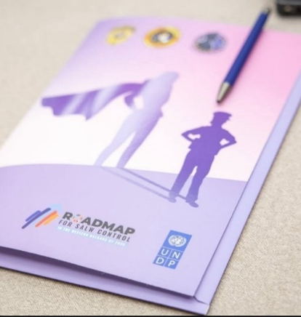
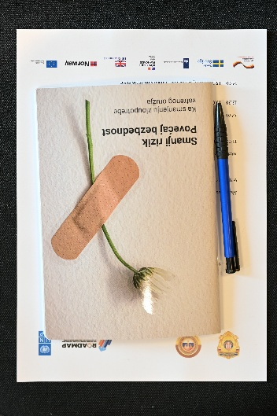
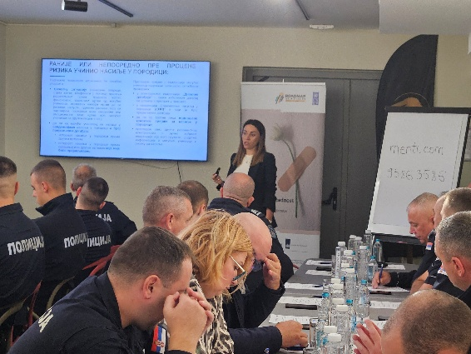
photo credit: first image credit: cabinet of minister without portfolio responsible for gender equality, other images: undp serbia
Resources developed through previous stages of the project, like the MoI e-classroom learning modules on DV prevention for police officers, as well as trainings on combating DV through multi-sectoral cooperation on the Judicial Academy’s online learning platform, have been promoted though project activities. Previously developed knowledge products were also utilized in the current work (e.g. the guidebook on health professionals’ response to domestic violence and guidebook for media reporting on violence against women).
Visibility guidelines were developed for and distributed to supported CSOs, based on visibility rules of the WB SALW Control Roadmap and UNDP, including proper logo use, acknowledging donors in printed materials and appropriate communication of project support through social media. Work of supported local NGOs was captured through social media highlights and media coverage (appearances of experts and activists). In addition to this, disseminated printed materials acknowledged the support of UNDP and WB SALW Control Roadmap donors. Below are several examples:

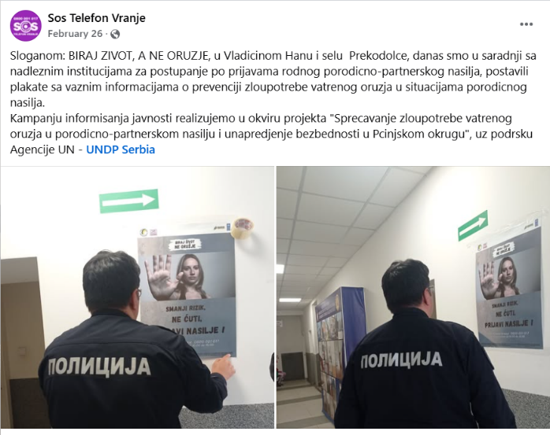
1.Social media post of the Human Rights Committee Vranje on the placement of posters at a local police station raising awareness on risks of firearms-enabled gender-based violence in local institutions: https://www.facebook.com/SOSvranje/posts/649083234155890
social media post on poster placement in local police station
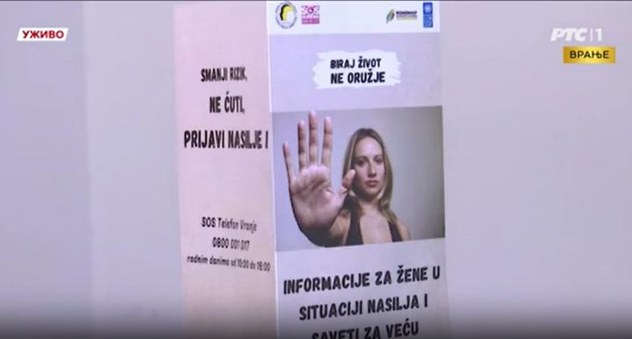
SCREENSHOT OF TELEVISION REPORT ON NATIONAL TV BROADCASTER SHOWING LEAFLET DEVELOPED AS PART OF UNDP-SUPPORTED LOCAL INITIATIVE IN VRANJE

1. | TV RTS1 – Fight against firearms misuse and femicides: project of the Human Rights Committee Vranje | Video
2. | Naslovi.net – Do women in South Serbia feel safe? | Link
3. | Bujanovacke.rs – A firearm in the house means fear, not safety: Women speak about security and violence | Link

2.The Women’s Centre Uzice continuously informed on dangers of firearms misuse for violence and project-supported activities through their social media channels (Facebook and Instagram) and through local podcast:
Podcast: https://www.youtube.com/watch?v=c0RUbrPqbNs&t=482s
Links to social media posts:
1. https://www.instagram.com/p/DIyOsyBMFPg/ | 2. https://www.instagram.com/p/DJ3p_EyIINy/?img_index=1
3. https://www.instagram.com/p/DLCnxNNor2N/ | 4. Reel on femicides: https://www.instagram.com/reel/DMM6JTYRgbC/
5.Reel on firearms misuse for domestic violence:
https://www.instagram.com/p/DMsIxM-umWb/
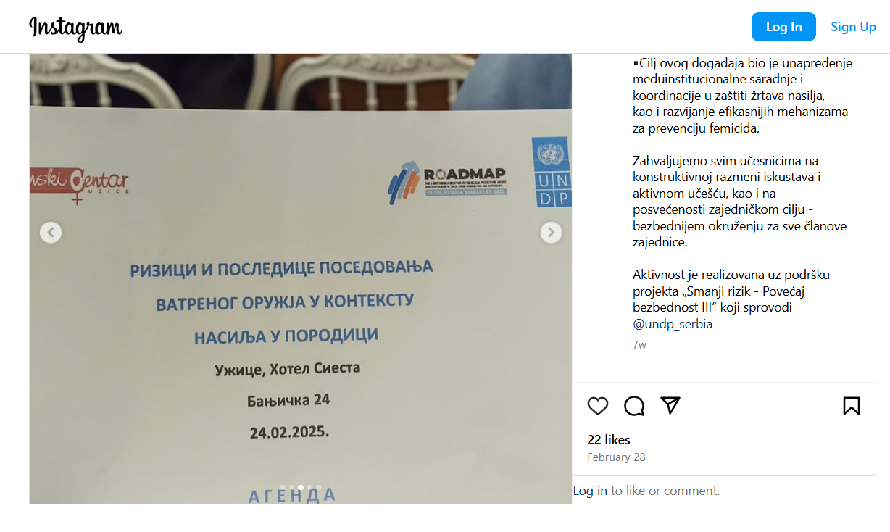
Social media post of the Women’s Center Užice on the project-supported roundtable discussion on firearms-enabled gender-based violence: https://www.instagram.com/p/DGm6ec1omPy/

3. The Zrenjanin Education Centre prepared social media posts and printed materials in 4 languages aimed at informing on risks of firearms-misuse for domestic violence and encourage survivors to seek help and report incidents and provided information of their activities through their website.
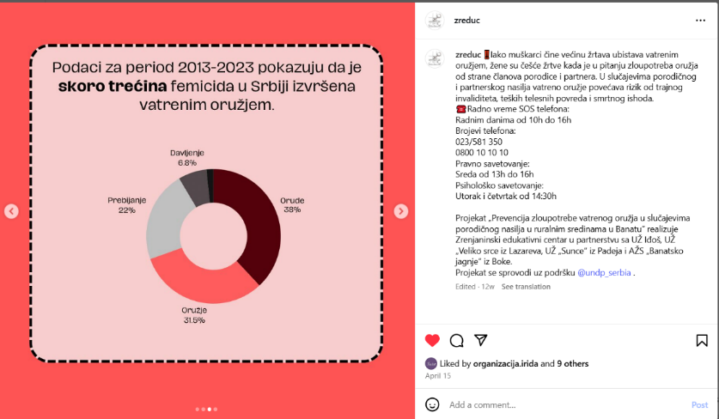
SOCIAL MEDIA POST INFORMING ON PREVALENCE OF FIREARMS MISUSE FOR FEMICIDES: https://www.instagram.com/p/DId3sTwooIH/?img_index=1

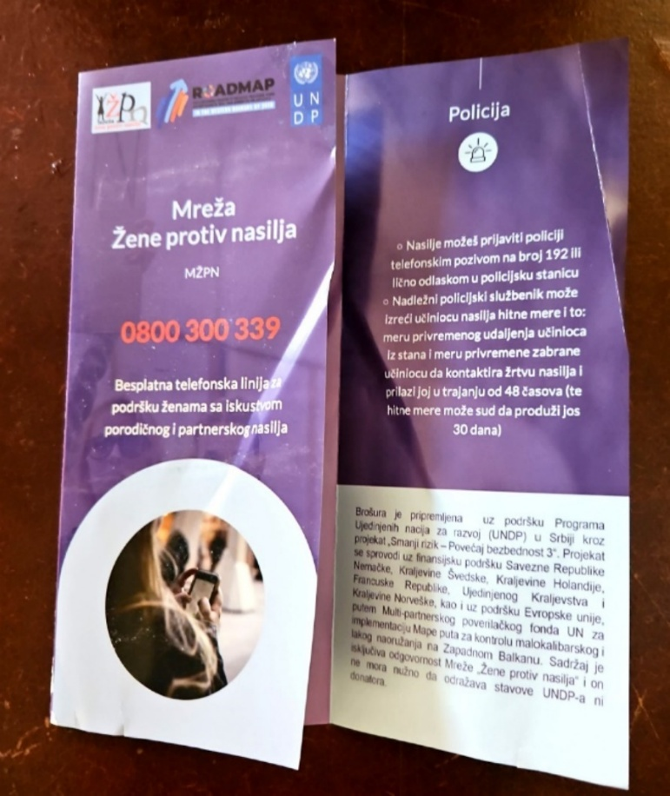
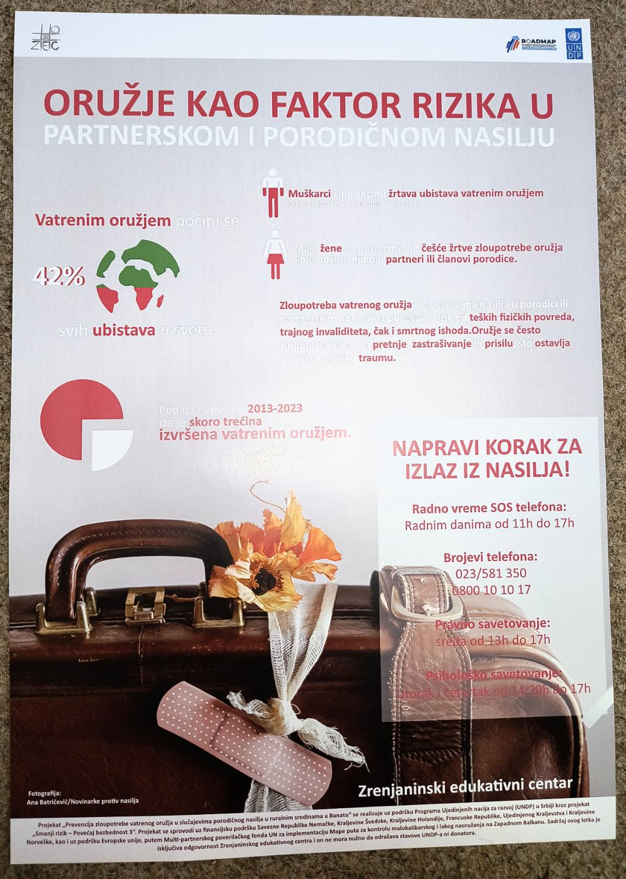
Lleaflets disseminated by women against violence network, credit: women against violence network
poster-infographic developed by the zrenjanin education center *photo used prepared by photographer previously involved in project supported training on ethical visual depiction of (firearms-enabled) violence against women, credit: zrenjanin education center

4. Media informed the public on risks of firearms-misuse for domestic violence, based on press conference held by the Association of women’s non-governmental organizations “Women against Violence Network”

1. | Radio Belgrade – program on firearm-enabled domestic violence | Link
2. | Politika Daily newspaper – article “Firearms in the home increase risk of femicide” | Link
3 | Media Center news portal – article on press conference | Link

To capture participants’ feedback and highlight the importance of (firearms-misuse) risk assessment and continuous professional training, a story was prepared on trainings conducted in the Autonomous Province of Vojvodina in partnership with MoI.
The 4th Annual Conference of Women in the Police of the Republic of Serbia attracted significant media attention, with over 20 reports on the event:
No. | Media | Link | No. | Media | Link
1 | rtv.rs | LINK | 2 | telegraf.rs | LINK
3 | tanjug.rs | LINK | 4 | nin.rs | LINK
5 | rtv.rs | LINK | 6 | rtv.rs | LINK
7 | tvpalmaplus.rs | LINK | 8 | naslovi.net | LINK
9 | tanjug.rs | LINK | 10 | euronews.rs | LINK
11 | Beta | LINK | 12 | rtv.rs | LINK
13 | politika.rs | LINK | 14 | postinfo.rs | LINK
15 | nsreporter.rs | LINK | 16 | nsreporter.rs | LINK
17 | telegraf.rs | LINK | 18 | RTS1 | Video
19 | naslovi.net | LINK | 20 | RTS1 | Video
21 | euronews.rs | LINK | 22 | Radio Novi Sad 1 | Video

Press release and social media posts on prime minister’s and ministers’ accounts further disseminated information on the event.
Marking September 10 – International Day of Suicide Prevention, information on the dangers of firearms-misuse for suicide and risk for men, as well as firearms safety advice in times of psychological crises was shared through UNDP’s social media channels:
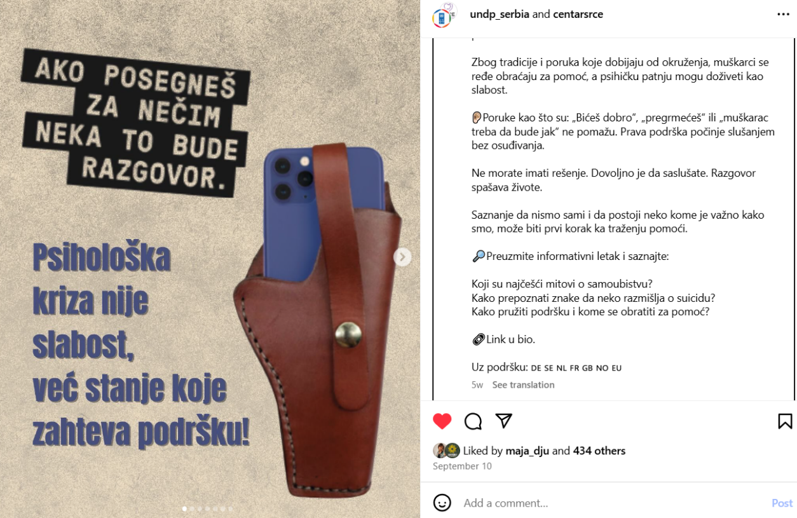

Additionally, the group “Journalists against violence” called on media to erase myths surrounding suicide by using Guidelines on Ethical Media Reporting on Suicide, developed in the previous project phase. Information on the guidelines was also shared by several journalists’ associations:
10.09.2025 | “Smernice za etičko izveštavanje o samoubistvima“ (Eng. “Guidelines on ethical media reporting on suicide”) | Association of journalists of Serbia - uns.org.rs | Link
10.09.2025. |  | Association of independent electronic media - anem.rs | Link

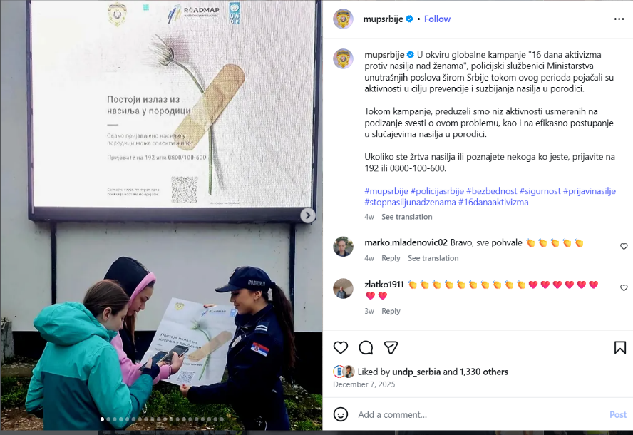
Furthermore, the Roadmap and UNDP logo were included in the MoI poster distributed nationwide during the “16 days of activism” campaign, providing further visibility of support to (firearms-enabled) violence prevention efforts within various communities, with the local actions covered by several media.

Komuna, 4 Dec 2025 RTV Bor, 1 Dec 2025
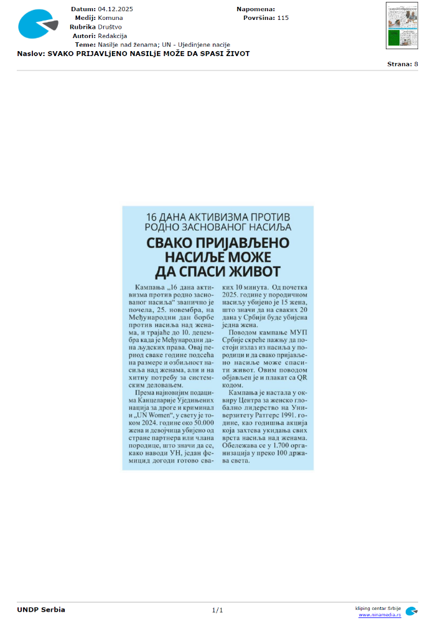
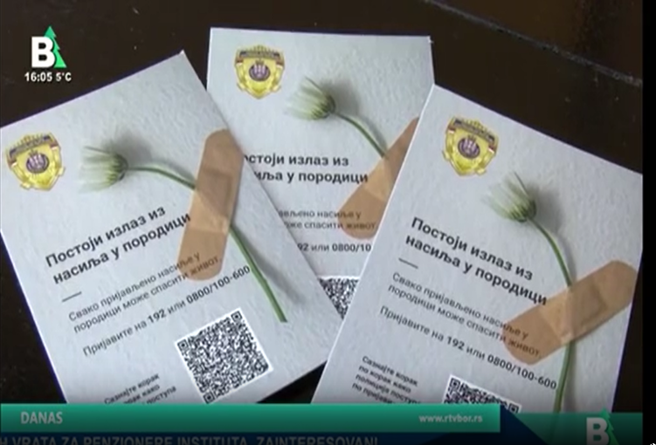

Strategic Results, as formulated in the Strategic UN Planning Framework (e.g. UNDAF) or project document;
The MPTF Office Project Reference Number is the same number as the one on the Notification message. It is also referred to as “Project ID” on the project’s factsheet page the MPTF Office GATEWAY
The MPTF or JP Contribution, refers to the amount transferred to the Participating UN Organizations, which is available on the MPTF Office GATEWAY
The start date is the date of the first transfer of the funds from the MPTF Office as Administrative Agent. Transfer date is available on the MPTF Office GATEWAY
As per approval of the original project document by the relevant decision-making body/Steering Committee.
If there has been an extension, then the revised, approved end date should be reflected here. If there has been no extension approved, then the current end date is the same as the original end date. The end date is the same as the operational closure date which is when all activities for which a Participating Organization is responsible under an approved MPTF / JP have been completed. As per the MOU, agencies are to notify the MPTF Office when a programme completes its operational activities.
Firearm Incidents in the Context of Domestic Violence – Western Balkans 2019-2024, UNDP SEESAC, available at: https://www.seesac.org/f/docs/in-focus-armed-violence-monitors_1/IN_FOCUS_Domestic_violence_Western_Balkans_2019-2024_w.pdf
Monitoring of femicide cases based on media reports by women’s CSO Femplatz, published on their social media channels: https://www.instagram.com/femplatz/
Report on women’s rights and gender equality in Serbia for 2023, women’s CSO Femplatz, available at: https://femplatz.org/library/reports/2024-03-19_PreneraZena_2023_SR.pdf , as well as Annual quantitative – narrative report on femicide for 2024, Women against Violence Network, available at: https://www.womenngo.org.rs/images/femicid/Izvestaj_o_femicidu_2024.pdf
Characteristics and Prevention of Intimate Partner Femicide – Suicide Cases committed with a Firearm, UNDP Serbia, 2023, available at:https://www.undp.org/serbia/publications/characteristics-and-prevention-intimate-partner-femicide-suicide-cases-committed-firearm
Gender and Small Arms in Serbia: Fast Facts, SEESAC, 2019, Gender and SALW in South East Europe, SEESAC, 2016
Vital statistics 2024, Statistical office of the Republic of Serbia: https://www.stat.gov.rs/en-us/vesti/statisticalrelease/?p=17029#:~:text=Table%202.&text=Population%2030.06.&text=In%20the%20Republic%20of%20Serbia%2C%20according%20to%20data%20for%202024,men%20and%202%20674%20women .
Vital statistics 2023, Statistical office of the Republic of Serbia: https://www.stat.gov.rs/en-us/vesti/statisticalrelease/?p=15197#:~:text=Table%202.&text=Population%2030.06.&text=In%202023%2C%20there%20were%2097,men%20and%202%20524%20women .
Statistical Office of the Republic of Serbia: https://data.stat.gov.rs/Home/Result/18030304?languageCode=en-US
https://www.seesac.org/f/docs/Armed-Violence/2024-AVMP---Inforgraphic-FINAL-1.pdf
https://www.seesac.org/f/docs/Armed-Violence/Firearm-incidents-in-SEE-in-2022.pdf
Firearm related suicides in South East Europe in 2021, https://www.seesac.org/f/docs/Armed-Violence/In-Focus-Armed-Violence-Monitor-on-Firearm-related-Suicides-in-SEE-in-2021.pdf
Fire-arm related suicides in South East Europe in 2020, https://www.seesac.org/f/docs/Armed-Violence/In-Focus-Armed-Violence-Monitor-Firearm-related-Suicides-in-SEE-in-2020_1.pdf
UNDP SEESAC 2024: https://www.seesac.org/f/docs/Gender-and-SALW/SEESAC---Analysis-of-media-reporting-ENG-digital.pdf
The spent amount should cover the period since the beginning of the project until the end of the reporting period.
The spent amount should cover the period since the beginning of the project until the end of the reporting period.
The spent amount should cover the period since the beginning of the project until the end of the reporting period.
The spent amount should cover the period since the beginning of the project until the end of the reporting period.
The spent amount should cover the period since the beginning of the project until the end of the reporting period.
The later if applicable.

